ERP Requirement Template
TNO : GLA0122
USER NAME :T.PRABHU
PROCESS FLOW :NEW REQUIREMENT
MODULE NAME :EXIM - IMPORT
COMPONENT NAME :OUTWARD REMITTANCE ENTRY
MENU LINK :TRANSACTION – FOREIGN OUTWARD – REMITTANCE RECEIPT ENTRY

SCREEN
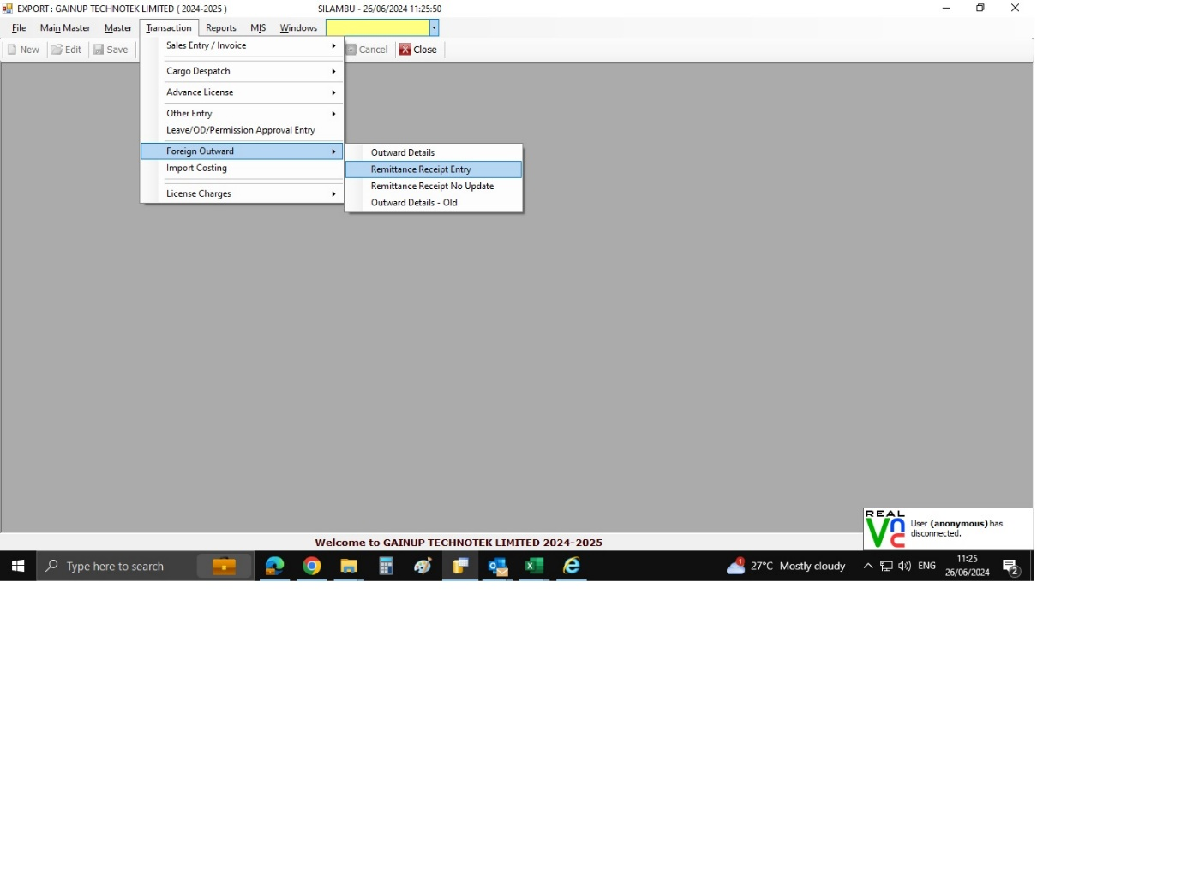

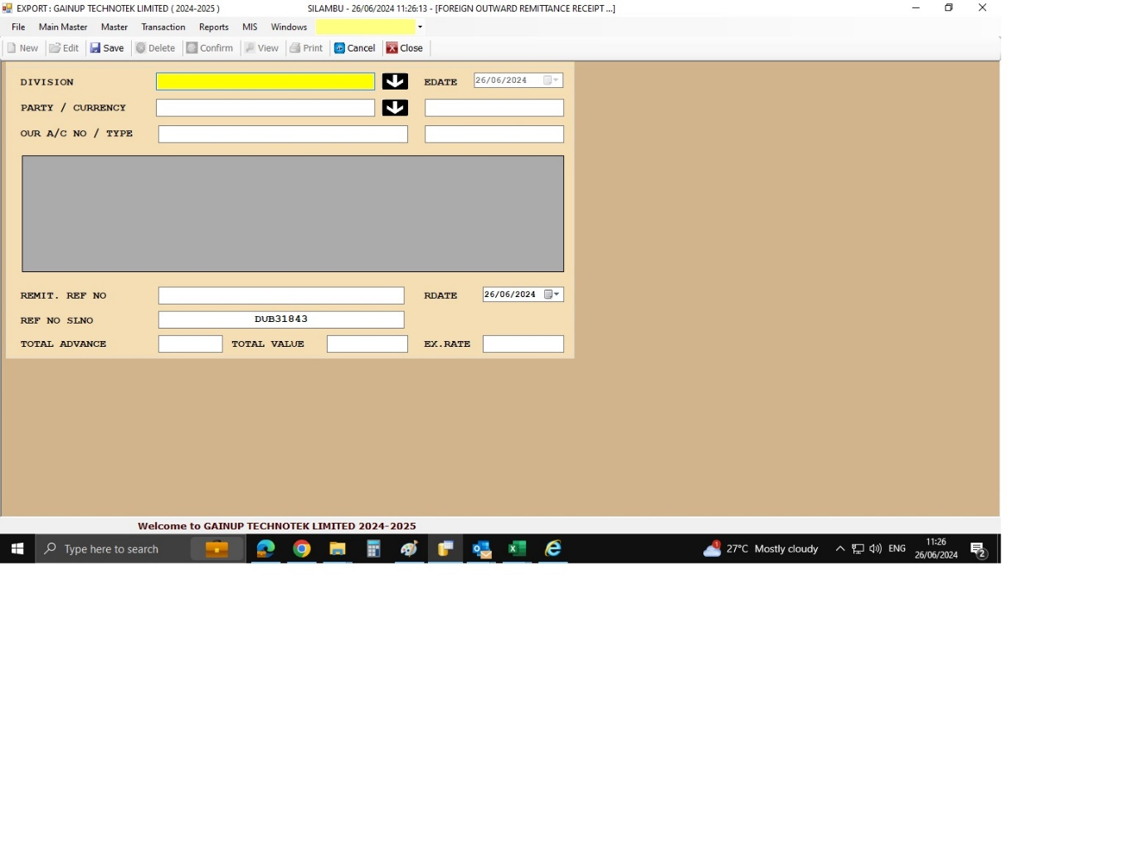
DESCRIPTION:
- OUTWARD REMITTANCE ENTRY

CONDITIONS:
1. WE NEED THE INVOICE NUMBER SELECTION OPTION FOR AT THE TIME PAYMENT REMITTANCE ENTRY
JOURNAL ENTRY (IF APPLIED):
NARRATION (IF APPLIED):

APPROVAL SCREEN REQUIRED?
NO
APPROVED BY:
APPROVAL MENU LINK:

REPORT REQUIRED?
NO
TYPE OF REPORT:
MIS
POWER BI
GRID REPORT
CRYSTAL REPORT
LIFE@GAINUP

REPORT FORMAT:

REMARKS:
OUTWARD REMITTANCE ENTRY – MANUAL ENTRY BANK REFERENCE NUMBER VISIBLE MULTIPLE INVOICE SELECTION OPTION

