**ERP Requirement Template**

**TNO :**

**USER NAME :**

**PROCESS FLOW :**

**MODULE NAME :**

**COMPONENT NAME :**

**MENU LINK**

**SCREEN**

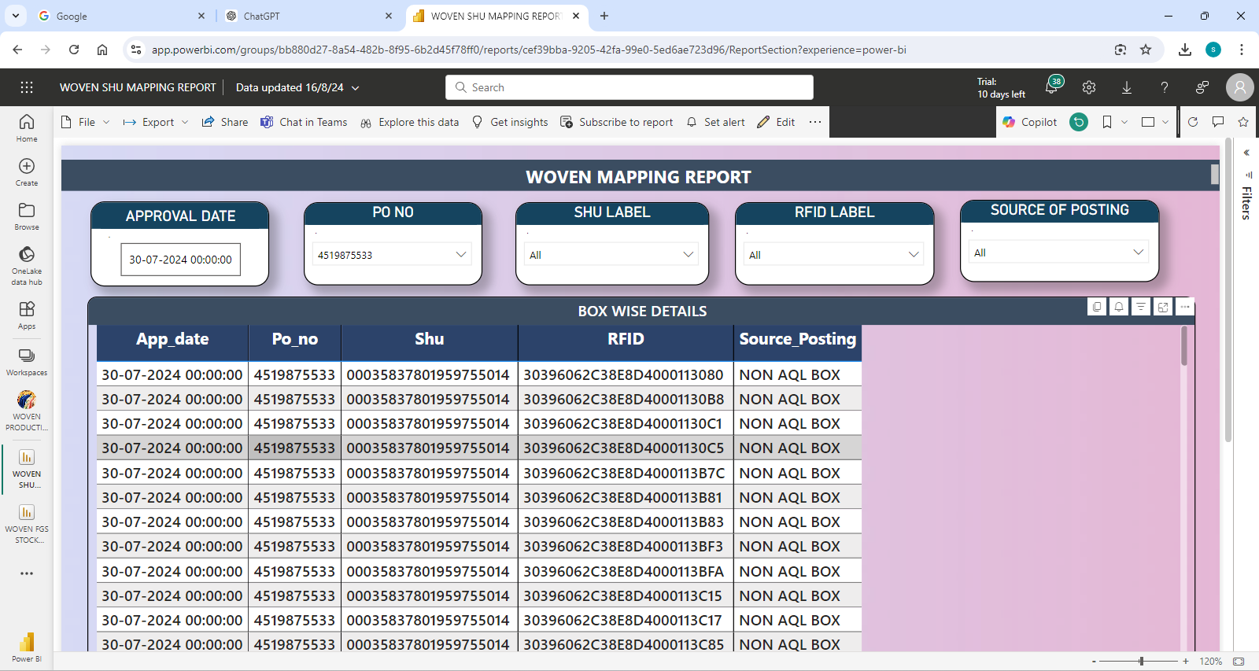

**DESCRIPTION:**

1.

2.

3.

4.

5.

**CONDITIONS:**

1.

2.

3.

4.

5.

**JOURNAL ENTRY (IF APPLIED):**

|  |  |  |  |
| --- | --- | --- | --- |
|  |  |  |  |
|  |  |  |  |
|  |  |  |  |
|  |  |  |  |
|  |  |  |  |

**NARRATION (IF APPLIED):**

**APPROVAL SCREEN REQUIRED?**

YES

NO

APPROVED BY:

**APPROVAL MENU LINK:**

**REPORT REQUIRED?**

YES

NO

**TYPE OF REPORT:**

MIS

POWER BI

GRID REPORT

CRYSTAL REPORT

LIFE@GAINUP

**REPORT FORMAT:**

|  |  |  |  |  |  |  |  |  |
| --- | --- | --- | --- | --- | --- | --- | --- | --- |
|  |  |  |  |  |  |  |  |  |
|  |  |  |  |  |  |  |  |  |
|  |  |  |  |  |  |  |  |  |

REMARKS:

|  |
| --- |
|  |