ERP Requirement Template
TNO :
USER NAME : ARUN PANDI.J
PROCESS FLOW : INTERTEK BILL CLOSE IN USD PRICE
MODULE NAME : WOVEN
COMPONENT NAME : GRN -TESTING INVOICE
MENU LINK

SCREEN

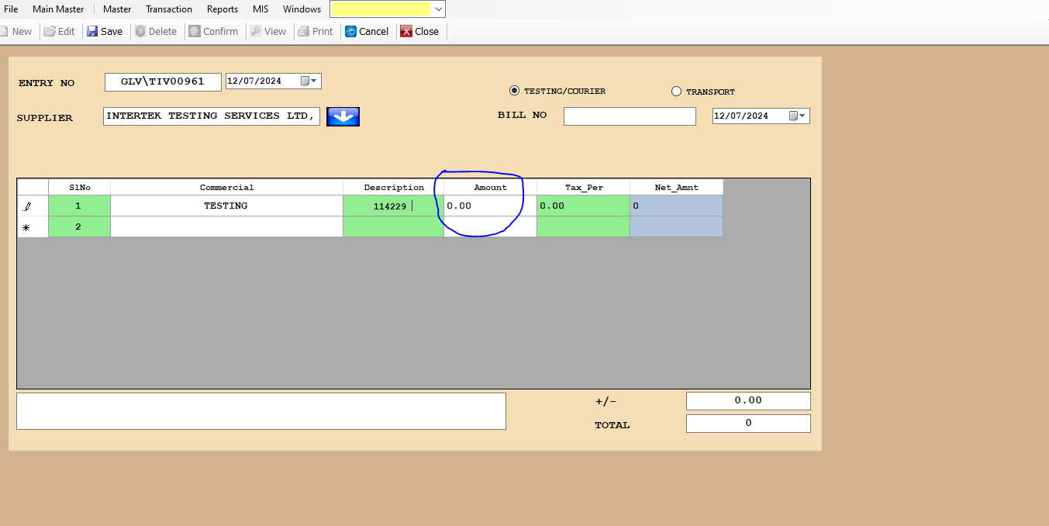

DESCRIPTION:
1. pls add USD value in Testing invoice
2.
3.
4.
5.

CONDITIONS:
1. we are change USD in Current market value
2.
3.
4.
5.
JOURNAL ENTRY (IF APPLIED):
NARRATION (IF APPLIED):

APPROVAL SCREEN REQUIRED?
YES
NO
APPROVED BY:

APPROVAL MENU LINK:

REPORT REQUIRED?
YES
NO
TYPE OF REPORT:
MIS
POWER BI
GRID REPORT
CRYSTAL REPORT
LIFE@GAINUP

REPORT FORMAT:

REMARKS:

