Shipment Management
Training Manual

ANNEXURE
S.No | SUBJECT | PAGE
1 | Shipment flow chart | 3
2 | Supply terminologies | 5
3 | Basics of Supply | 7
4 | CUSTOM ZONES & FORWARDER DETAILS | 9
5 | INCOTERMS | 11
6 | LINK BASICS | 11
7 | CAPE BASICS | 20
8 | SHU INFORMATION | 26
9 | DOCUMENTATION | 27
10  11 | GEODIS UPDATE  LOGISTICS CONTACT DETAILS | 34  43
1.SHIPMENT FLOW CHART

To take upcoming 4 weeks shipment PO from the master file

Cross check with weekly shipments with the LINK tool

Shipment plans to be discussed along with the planner, merchants and review the alerts.

To create AS on time
DSI- a week’s before the EHD
EU- As per the cut off
CBRS- As per the sailing schedule

To prepare the documents( PO, PL SHU print etc)

Handover to packing team

Packing team offer the PO’s quality team for inspection

Inspection is OK, we can go forward for Dispatch. If noy ok, need to revise EHD as per re-offer date

If inspection is OK, to dispatch it to the designation

2. SUPPLY TERMINOLOGIES

- PO - Purchase Order
- SPL – Supply Production Leader
- AS – Available for Shipment
- CAC – Continental Warehouse
- CAR – Regional Warehouse
- RS – Retail Supplier
- IMAN NO – Style No
- MODEL CODE – Color Code
- ITEM CODE – Individual Size Code
- CUSTOM ZONE – Retail Countries
- PCB – Pieces Per Carton Box
- UE/PCB – Unit Equivalent (Pieces Per Bundle)
- SHU LABEL – Shipment Unit Label.
- Order Status
- NV – Non-Validated
- UC – Unconfirmed
- PS – Pre- Selected for Supplier
- SU – Supplier Un Confirmation
- VS – Confirmed by Supplier
- V – Validated

15. GTD - General Terms of Delivery.
16. RFID - Radio Frequency Identification Device . 17 . CBM - Cubic Metre.
18. CLP - Container loading Plan.
19. ALP - Air Loading Plan.
20. EHD - Estimated hand-over date.
21. EDD - Estimated Delivery Date.
22. ESD - Estimated Shipment Date.
23. ETD - Estimated Time of Departure. 24. ETA - Estimated Time of Arrival.
25. ATD - Actual Time of Departure .
26. ATA - Actual Time of Arrival .
27. CHD - Contractual hand-over date. 28. CDD - Contractual Delivery Date.
29. CSD - Contractual Shipment Date.
30. HOT - Handover On Time.

3. Basic Supply
Implantation Order Flow
The first set of PO (Purchase Order) of a season. In the ideal case, it will be approximately 35%-40% of the selection quantity, it may differ according to the brands. Since this is the first order of the season it will have a firm full LT.
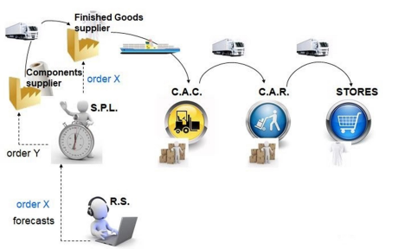

Replenishment Order Flow
The orders which are getting released after implantation are called replenishment orders. The Decathlon system will generate the replenishment orders based on the sales, stock and orders in the system. In such scenarios, these orders will have only production + Transportation LT, because the component and trims will be in stock.

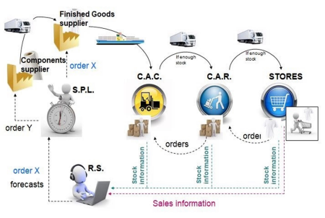

4. CUSTOM ZONES & FORWARDER
For decathlon we are shipping the goods to different countries which are called custom zones.

EU CUSTOM ZONES & (FORWARDER)
- CAC ROUVIGNIES (GEODIS)
- CAC EVIN (GEODIS)
- CAC ST MARTIN (EXPEDITORS)
- CAC DOURGES BASE CAMP (GEODIS)
- CAC ZARAGOZA (EXPEDITORS)

OTHER CUSTOM ZONES & (FORWARDER)
- BOOSTER MALAYSIA (EXPEDITORS)
- BOOSTER EMEA (EXPEDITORS)
- CAC TURKEY (GEODIS)
- BOOSTER LATAM (EXPEDITORS)
- CAC THAILAND (EXPEDITORS)
- CAC MONTREAL (EXPEDITORS)
- BOOSTER INDIAN OCEAN (EXPEDITORS)
- CAC BARUERI (EXPEDITORS)
- CAC SANTIAGO (EXPEDITORS)
- CAC MEXICO (EXPEDITORS)
- CAC MOSCOW (EXPEDITORS)
- CAC/CAR COLOMBIA (EXPEDITORS)

DOMESTIC ZONE
- DSI CAC Bangalore
- DSI CAC DELHI

GEODIS TRAINING LINK:
https://drive.google.com/file/d/1N93ByqZTat90x8AswtcNCa-7dHWr4Ja6/view?usp=gmail&ts=642eb991&sh=uq3tjMYDI2lCcGeh&ca=1
5. INCOTERMS
Incoterms are a set of rules which define the responsibilities of sellers and buyers for the delivery of goods under sales contracts. They are published by the international chamber (ICC)and are widely used in commercial transaction.
INCOTERMS: INTERNATIONAL COMMERCIAL TERMS
Incoterms We Use:
FOB – Freight on Board. We Use These Terms for Export SEA Shipment for EUROPE & BRCTA.
EX WORK – Where Buyer Pick Up the Order from the supplier’s place. We Use This Term Only For DSI.

TOOLS IN DECATHLON
5. LINK TOOL
Introduction
It Is A Tool Which Helps Us To Create A Stronger Link Between Us And Decathlon , The Main Objective Of This Tool Is To Manage And Understand The New Process Of Order Validation And Follow Up.
WEB ADDRESS – https://link-as.decathlon.net/extprod/index.jsp?sap-client=042&sap-language=EN#~%2Fextprod%2Forder%2FdisplayOrders.do_1
How to print PO
use the above web address to access LINK. Below is the home page.
Enter username: Chandrasekaran@gainup.in
Password: Gut@wg2023!
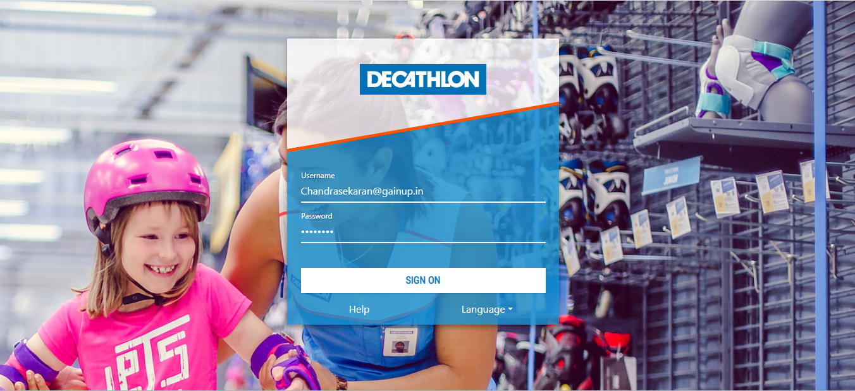
Below is the cockpit, from here we can access the different tools like LINK , CAPE ,etc.. , select LINK to print PO

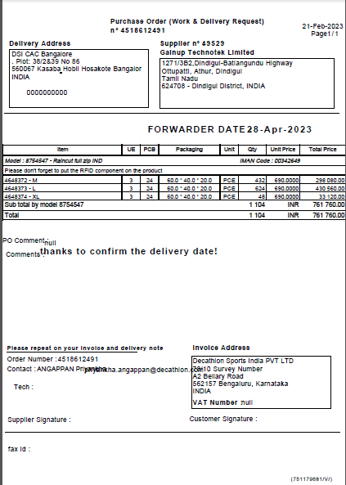

Below is the home page of LINK, you have to select the customer (DP INDIA or DSI) , by default select DP India. Select DP India and press enter, you will get the below screen.
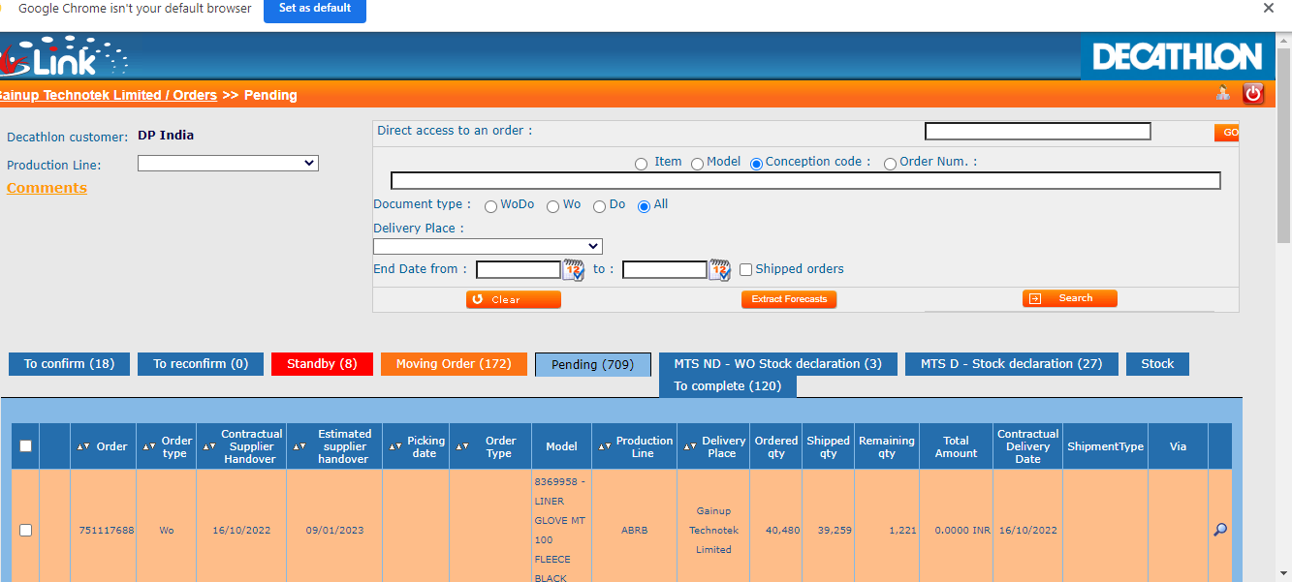

Enter order number in direct access to an order box to print PO and click search.

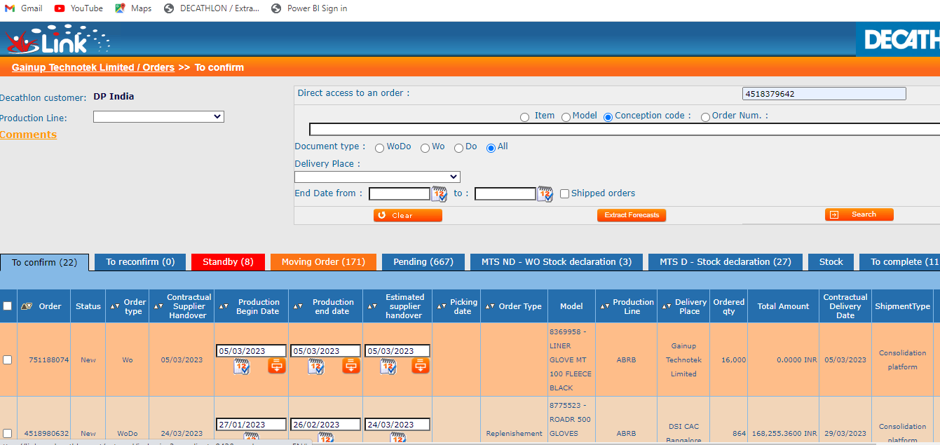
You will get the below screen ; in that you must press PDF icon to print
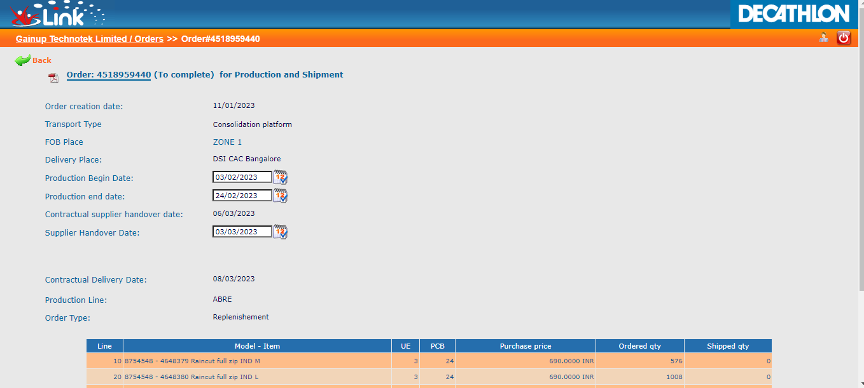
The PO screen will pop up, then you can print or save the PO.
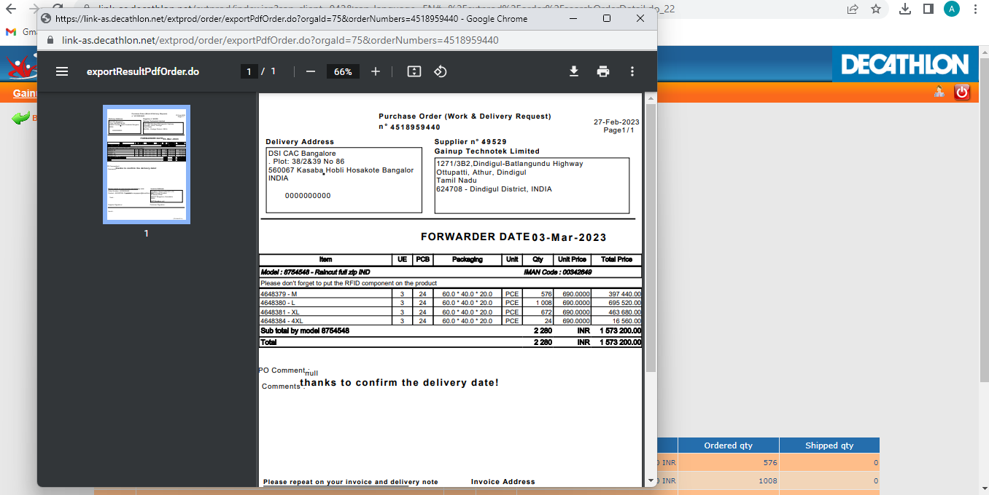
To print multiple PO’s, copy paste multiple PO numbers from excel to order number box and clock search.
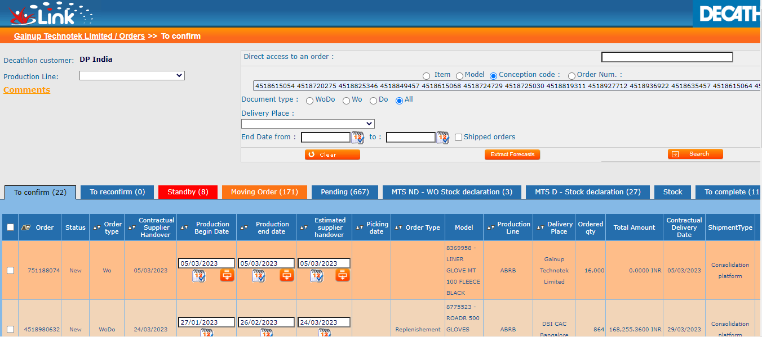
In the below screen you must select all and give print or download according to your requirement.
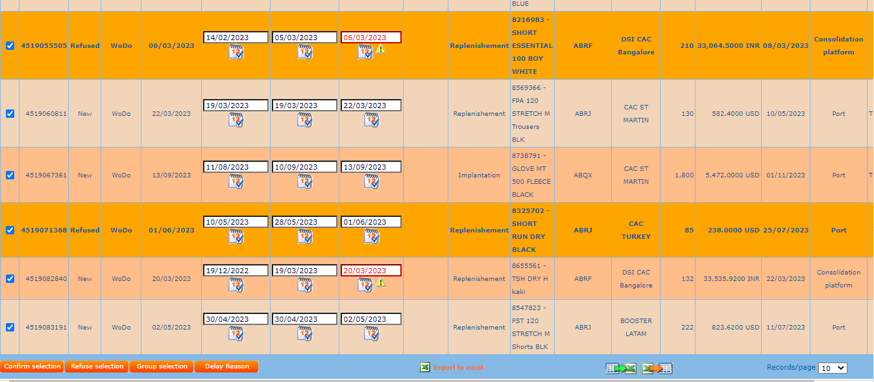
6. CAPE
Introduction
A communication tool between decathlon and supplier through which we can create, delete, or update AS saying the goods are ready for shipment. Using the same we can also update EHD and generate SHU sticker.
WEB ADDRESS – https://cape-asia.decathlon.net/capetm/index.jsp
What is AS
AS available for shipment, order should be ready for shipment. an order in AS status gives the visibility to everyone that the order is ready for shipment.
Why does AS need to be created?
- AS status gives the clear view that the order is ready for shipment.
- Expeditors plan the cargo volume with the orders in as status. if it is not created on time based on cut off, planning of cargo volume will be affected.
- Every Wednesday as to be created for next week hand over for Europe and for other custom zone follow the as creation cut off mention in the sailing schedule.

AS CREATION STEPWISE:
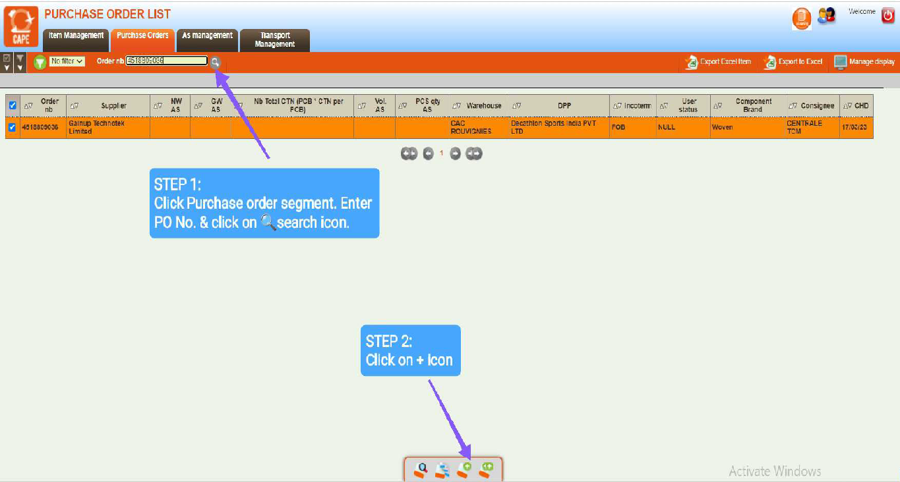

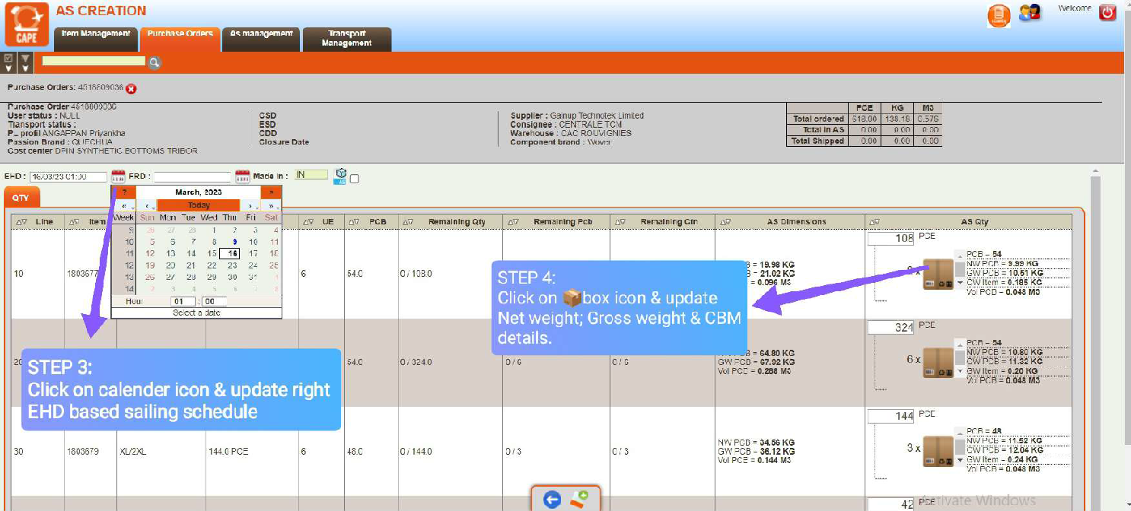

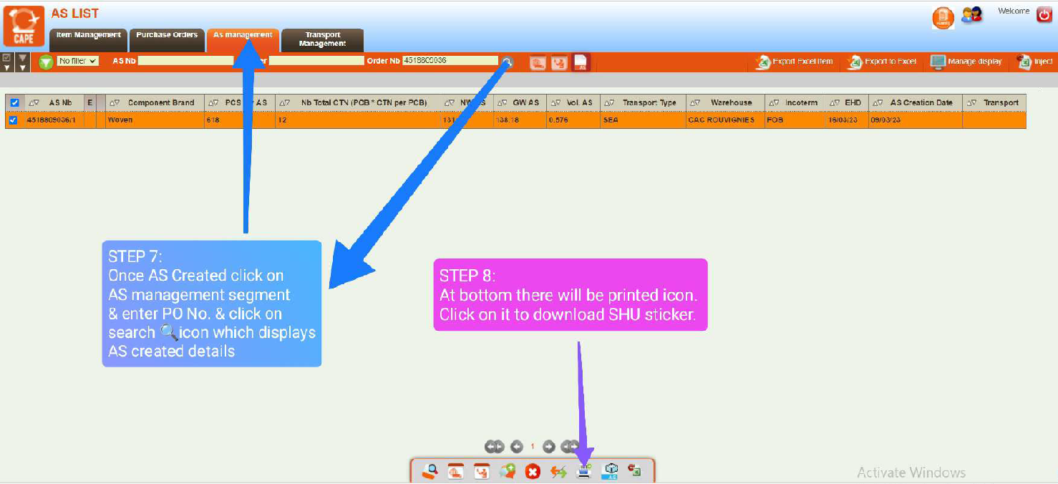

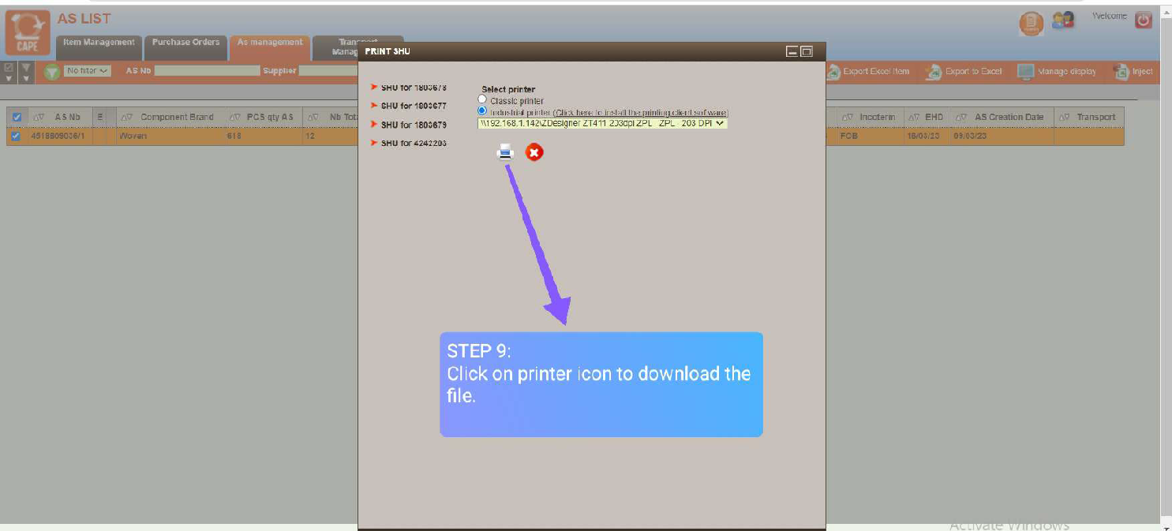
7. HOW TO PRINT SHU?
https://drive.google.com/drive/folders/1UwiX_y4u3DFeKeTPVYca5mzRg0T0pTK2

8. DOCUMENTATION
- For Europe shipment based on the AS creation list (which was created on Wednesday) the forwarder will send the carting order on Friday for next week handover.
for example, in week 1 on Wednesday we create AS for the week 2 EHD handover and for the same you receive the carting order from logistics on Friday, week 1
2. For CBRS based on the sailing schedule the forwarder will release the carting order.
(AS cut off – based on sailing schedule file cut off dates)
3. For India based on the EHD, every week Thursday we need to send the booking file to decathlon logistic team to arrange the truck for pick up on Friday.
EXPORT DOCUMENTS:
1. Invoice
2. Packing List
3. AS Sheet
4. VGM – Verified Gross Mass
5. GTD Scan Report
6. COO – Certificate of Origin
7. FORM AI (If Required)
8. REX (Registered Export System) Invoice (If Required)(Applicable for EUROPE)

DSI SHIPMENT DOCUMENTS
1. Invoice
2. Packing List
3. E-way Bill

Export document specimens
1.Invoice
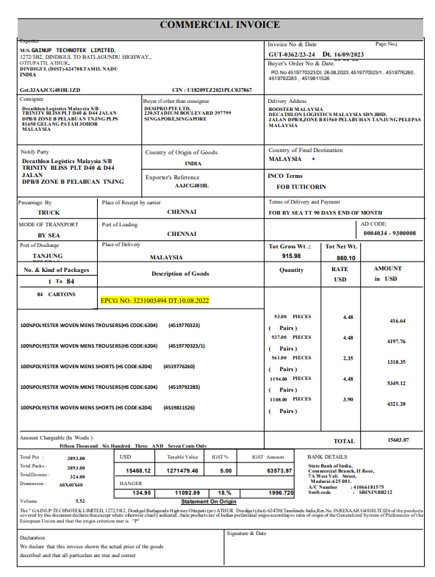

2. Packing list
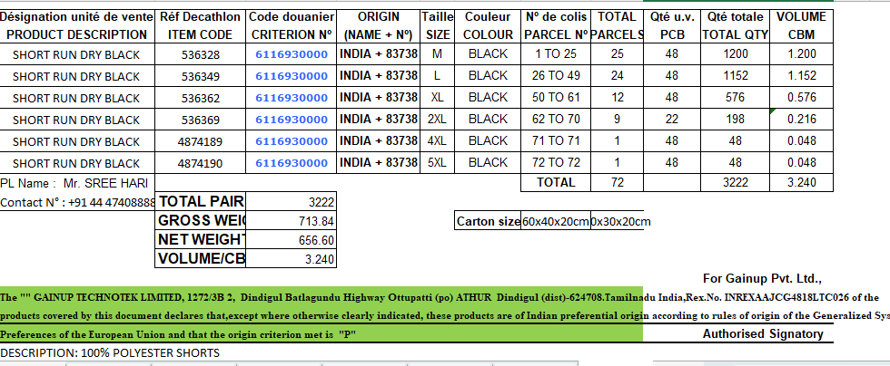
9. GEODIS- UPDATE
General Overview
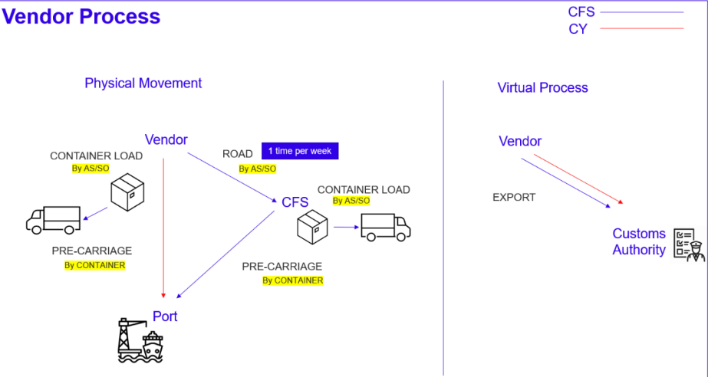

Log in Procedure : Common for both CY/CFS Flows

➢ Container Load Event Update & Documents upload (Page 6 – 8 )

3. DSI INVOICE
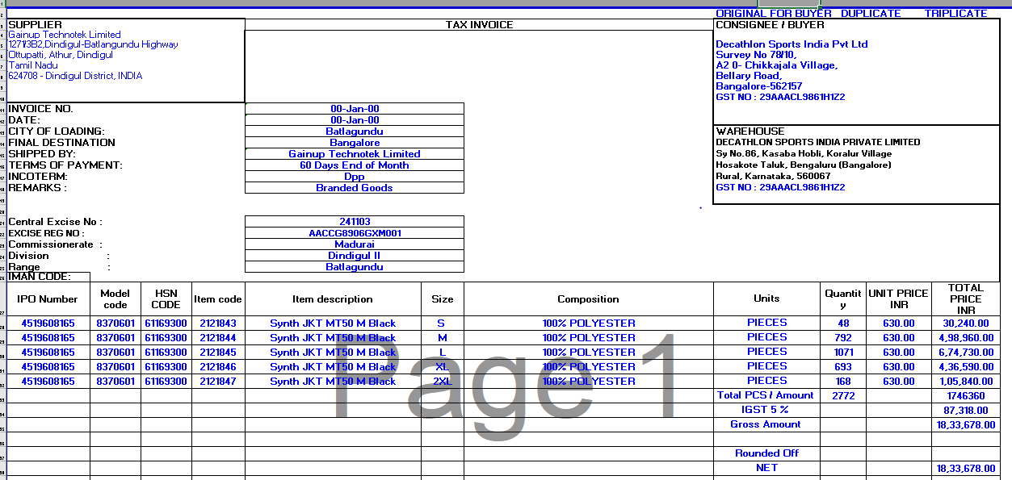

4. DSI PACKING LIST
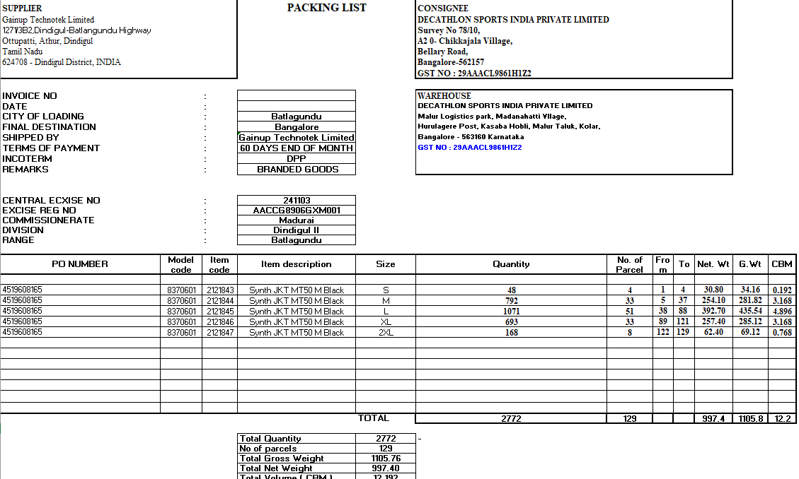

- LOGISTIC CONTACT DETAILS

DECATHLON POINT OF CONTACT:
POINT OF DECATHLON | DESIGINATION | CONTACT NO | EMAIL
Ms.Simran Kaur | INDIA EXPORTS - CBRSM SHIPMENT | 8860873488/ 8168298327 | simrankaur.sidana@decathlon.com
Mr.Karthick Nambiyar | INDIA EXPORTS - EUROPE SHIPMENT | 9755552172 | karthik.nambiar@decathlon.com
Mr. Sachin | INDIA EXPORTS |  | sachin.kumar@decathlon.com
Mr.Chingappa | INDIA IMPORTS - DSI | 9632996950 | chingappa.devaiah@decathlon.com
EXPEDITORS/GEODIS POINT OF CONTACT (DMI):
POINT OF DECATHLON | DESIGINATION | CONTACT NO | EMAIL
Mr.Ramesh Kumar | EUROPE SHIPMENT | 9344351961 | Ramesh.Kumar@expeditors.com
Mr. Baskar | CBRS SHIPMENT | 9941070199 | Baskar.P@expeditors.com
Mr. JANAKI RAMAN | EUROPE SHIPMENT | 8448693772 | janakiraman.veerappan@geodis.com
Mr. VENKAT REDDY | EUROPE SHIPMENT |  | Venkata.reddy@geodis.com
WAREHOUSE POINT OF CONTACT (DSI):
POINT OF DECATHLON | DESIGINATION | CONTACT NO | EMAIL
Mr.Subhajit | DSI WAREHOUSE LEADER | 8073187952 | mohammed.sameer.partner@decathlon.com
SPL POINT OF CONTACT
POINT OF DECATHLON | DESIGINATION | CONTACT NO | EMAIL
Ms.Priyanka | ARTENGO/KALENJI | 7010529188 | priyankha.angappan@decathlon.com
Mr.Thejas | DOMYOS/FORCLAZ | 9176889807 | thejasj.muttathu@decathlon.com
Mr. Prasad | WEDZE/QUECHUA | 9731465240 | prasath.panchavarnam@decathlon.com
GAINUP POINT OF CONTACT:
POINT OF DECATHLON | DESIGINATION | CONTACT NO | EMAIL
Mr. RAMAR | DMI –Exports Team | 80722 84464 | ramar.a@gainup.in
Mr. SARAVANAN | DMI –Exports Team | 78716 95227 | saravanakumar.s@gaiup.in
Mr. SUNDHARESAN | DSI Shipment | 85267 44725 | sundharesan.p@gainup.in

