ERP Requirement Template
TNO : GSA0116
USER NAME : M.MURUGAPANDI
PROCESS FLOW :

MODULE NAME : V BILL
COMPONENT NAME : SALES INVOICE
MENU LINK
Transaction YARN – SALES INVOICE

SCREEN
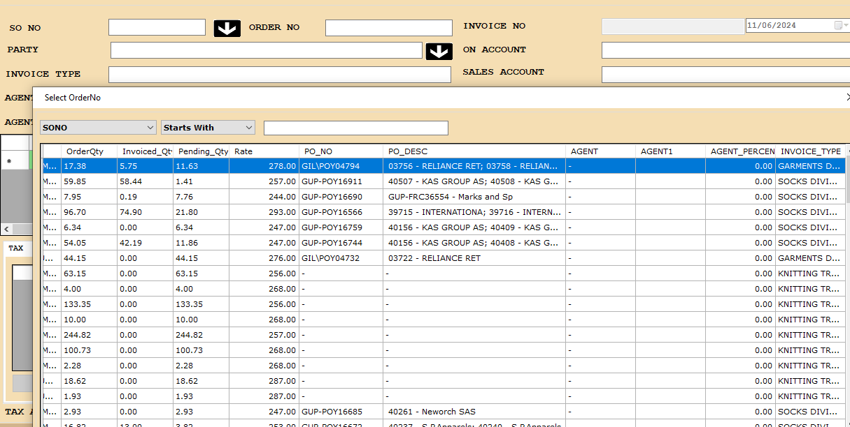

DESCRIPTION:
1. in cancel New option I Yarn Sales invoice Screen, highlight the Shipped OCNs based on OCN/PO.
JOURNAL ENTRY (IF APPLIED):NA
NARRATION (IF APPLIED):
NA
APPROVAL SCREEN REQUIRED
NO
APPROVED BY:
NA
APPROVAL MENU LINK:
NA
REPORT REQUIRED?
YES
TYPE OF REPORT:
GRID REPORT

REPORT FORMAT:

REMARKS:

