ERP Requirement Template
TNO : GHA0001
USERNAME : SELVAKUMARESAN S
PROCESS FLOW : INVOICING ENTRY
MODULE NAME : HEADWEAR
COMPONENT NAME : INVOICING
MENU LINK
HEADWEAR-TRANSACTION-GRN-INVOICING ENTRY

SCREEN
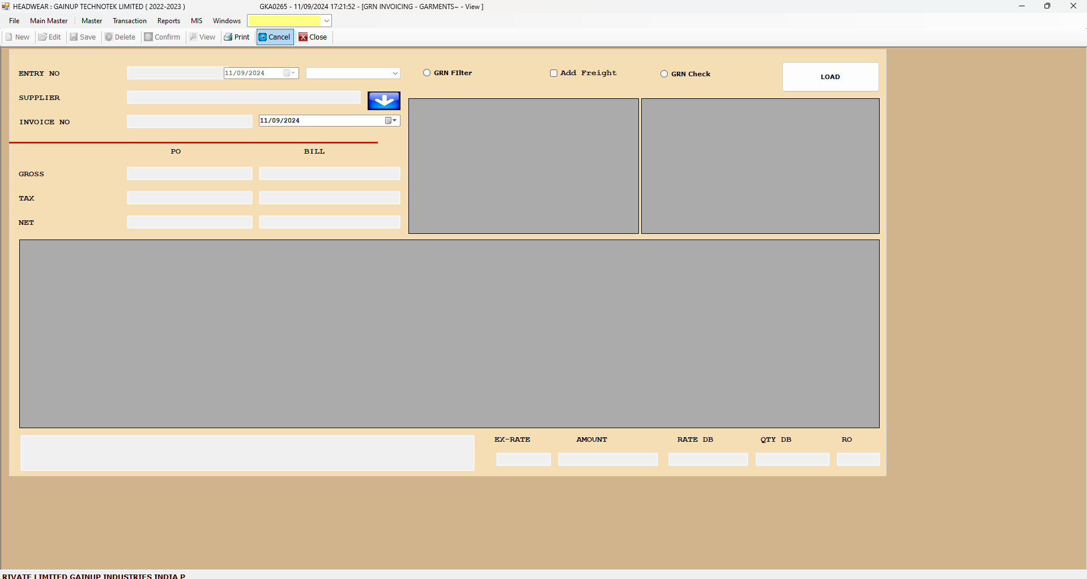

DESCRIPTION:
1.
2.
3.
4.
5.

CONDITIONS:
1.
2.
3.
4.
5.
JOURNAL ENTRY (IF APPLIED):
NARRATION (IF APPLIED):

APPROVAL SCREEN REQUIRED?
YES
NO
APPROVED BY:

APPROVAL MENU LINK:

REPORT REQUIRED?
YES
NO
TYPE OF REPORT:
MIS
POWER BI
GRID REPORT
CRYSTAL REPORT
LIFE@GAINUP

REPORT FORMAT:

REMARKS:

