ERP Requirement Template
TNO :
USER NAME : GHA0022
PROCESS FLOW : Quality Rework rejection entry
MODULE NAME : Headwear
COMPONENT NAME : Others (Quality Entry)
MENU LINK
Production ->Transaction -> Cut order flow-> Sewing production

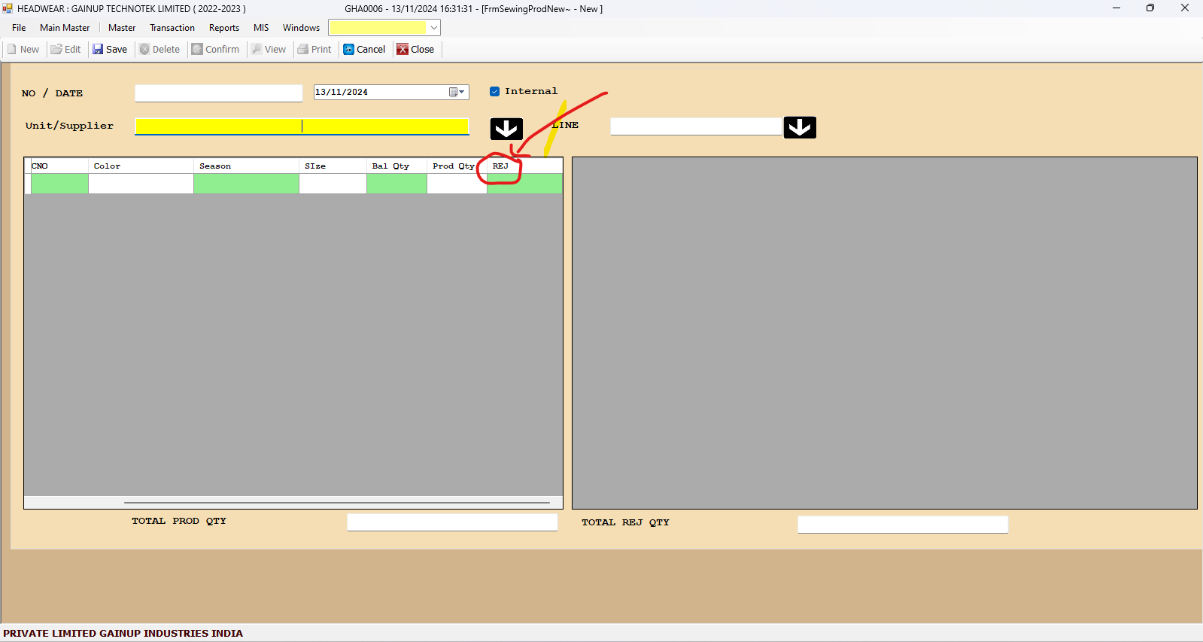
SCREEN

DESCRIPTION:
1. Rework entry need to be included in this window,
2. Access required only from GHA0022 Username and not in GHA0006 (production window) for both rework and rejection entry.

CONDITIONS:
1. Allow only view option in Username GHA0006.
2. Entry access required in Username GHA0022.
JOURNAL ENTRY (IF APPLIED):
NARRATION (IF APPLIED):

APPROVAL SCREEN REQUIRED?
YES
NO
APPROVED BY:

APPROVAL MENU LINK:

REPORT REQUIRED?
☒ YES
☐NO
TYPE OF REPORT:
☐ MIS
☒ POWER BI
☐ GRID REPORT
☐ CRYSTAL REPORT
☐LIFE@GAINUP

REPORT FORMAT:
Pareto chart for rejection and rework separately.
REMARKS:

