ERP Requirement Template
TNO : GGA0489
USER NAME : VENKATESWARAN
PROCESS FLOW : BANK IMPORT
MODULE NAME : ACCOUNTS
COMPONENT NAME : BRS IMPORT
MENU LINK: BRS IMPORT

SCREEN
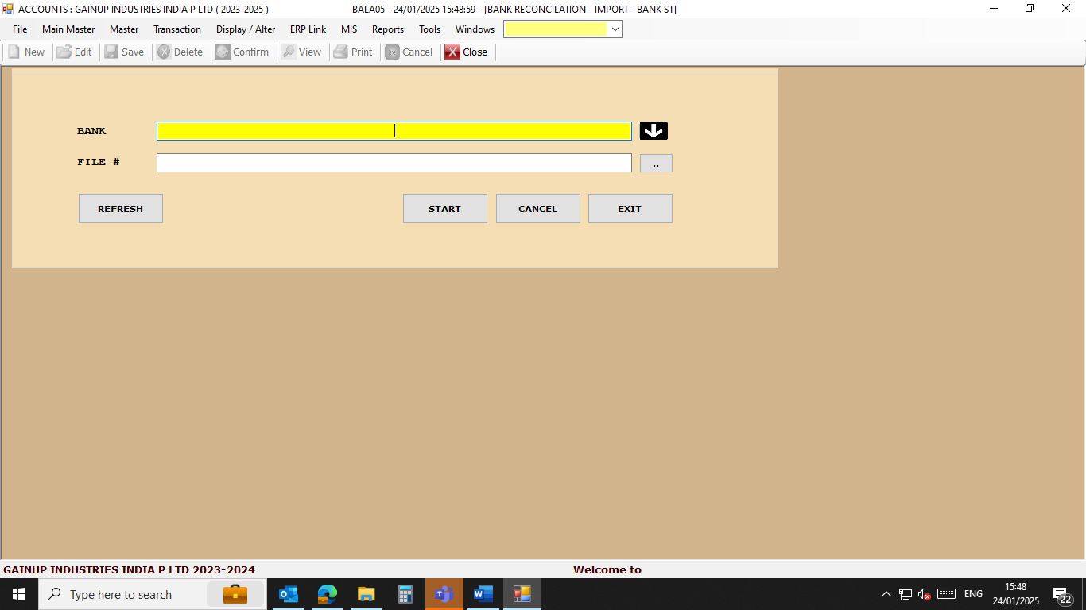

DESCRIPTION:
1. We need to upload bank statements to ERP which is downloaded from bank site without editing.
2. We need to upload SBI, HDFC , CANARA, and Axis
3.
4.
5.

CONDITIONS:
1. Bank BRS to be done.
2.
3.
4.
5.
JOURNAL ENTRY (IF APPLIED):
NARRATION (IF APPLIED):

APPROVAL SCREEN REQUIRED?
YES
- NO
APPROVED BY:

APPROVAL MENU LINK:

REPORT REQUIRED?
YES
- NO
TYPE OF REPORT:
MIS
POWER BI
GRID REPORT
CRYSTAL REPORT
LIFE@GAINUP

REPORT FORMAT:
SBI
Txn Date | Value Date | Description | Ref No./Cheque No. | Branch Code | Debit | Credit | Balance
23/01/2025 | 23/01/2025 | TO CLEARING-Chq No. 669256 TMB K BALAGURU NADAR--669256 | / 669256 | 10395 | 32295 |  | ########
23/01/2025 | 23/01/2025 | BY TRANSFER-INB-- | CT00MLTUN6 TRANSFER FROM 39104663611 GAINUP INDUSTRIES INDI / | 99922 |  | 1900000 | ########
23/01/2025 | 23/01/2025 | TO CLG CHQ-Chq No. 642107 HDF TO CLEARING CHEQUE--642107 | / 642107 | 4034 | 454503.3 |  | ########

REMARKS:
All bank statement with share in mail

