ERP Requirement Template
TNO :
USER NAME : P.KUMARESWARAN
PROCESS FLOW : Warning message entry/removal and view in Entry mode and
Ledger view
MODULE NAME : Accounts
COMPONENT NAME : All
MENU LINK : Display/Alter – Ledger View

SCREEN
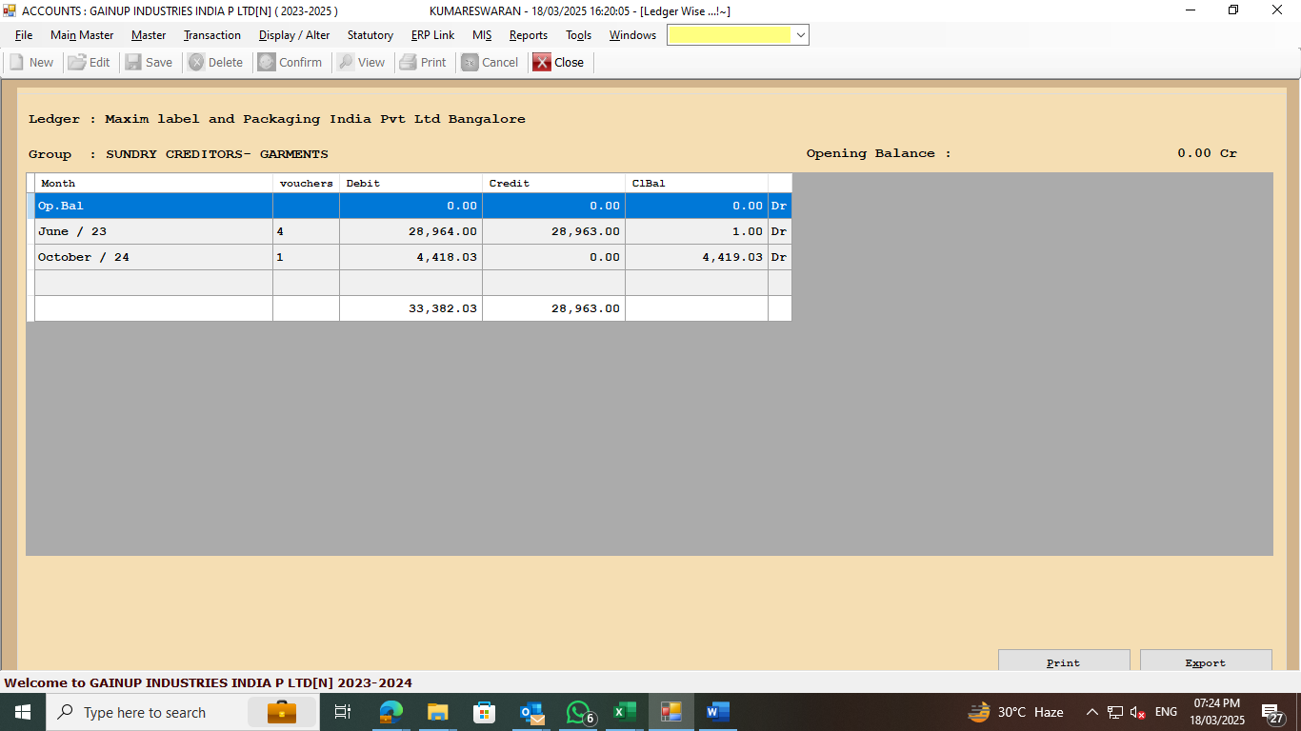
DESCRIPTION:
1. Outstanding amount due to GST/TDS should be known while making new entries
2. GST non filer warning message to pop-up while making new entries
3. During Ledger view, the warning message displays will alert
4.
5.

CONDITIONS:
1. Warning message entry allow to all
2. Warning message removal rights allow to VP-F/FM/AM/Arunagiri
3.
4.
5.
JOURNAL ENTRY (IF APPLIED):
NARRATION (IF APPLIED):

APPROVAL SCREEN REQUIRED? NO
YES
NO
APPROVED BY:

APPROVAL MENU LINK:

REPORT REQUIRED? YES
YES
NO
TYPE OF REPORT: GRID REPORT
MIS
POWER BI
GRID REPORT
CRYSTAL REPORT
LIFE@GAINUP

REPORT FORMAT:
Ledger Name | Warning Message

REMARKS:

