Sales Return Entry-Export
Ticket Raised | Flow given | Approval Given by HOD | Document Prepared | Understanding Document | Allocated to Developer | Testing completed | User acceptance
10/06/23 | 15/06/23 | 15/06/23 | 30/06/23 | 30/06/23
Ticket No:18163
Ticket Raised By Mr.Ramar
Sales Return Entry-Export

Allocated Time: Hours Allocated To: Mr. Joshua Approved By:Mr.Saravanamuthu
Description:
To enable the Sales Return Entry for Export and Bill passing for such Return Entry.
Module name:
Export
Accounts
Department Login:
Export
Accounts
Menu Link
At Export
Transaction Sales Entry/Invoice Sales Return
At Accounts
Authorize Export Sales Return
Vouchers:
Creditnote
Applicable companies:
1.Gainup Industries
2.Gainup Technotek

Provisions:
1.Sales Return Entry
2.Sales Return Entry Approval Screen
3.Accounts Bill passing screen
Conditions
1.Sales return entry should be raised only against sold invoices,
2.if Return entry made then PO, OCN will be enabled for next invoicing.
3.Stock of the returned quantity should be added to FGS.
4.Such sales return goes to Accounts Bill passing as Credit note voucher entry.
Table Structure:

Forms to be Used:
Sample Screen for Sales Return:
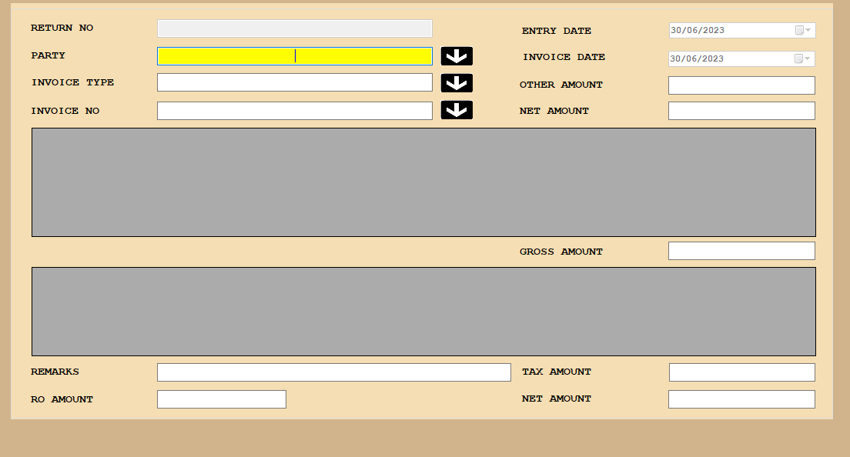

screen for Approval
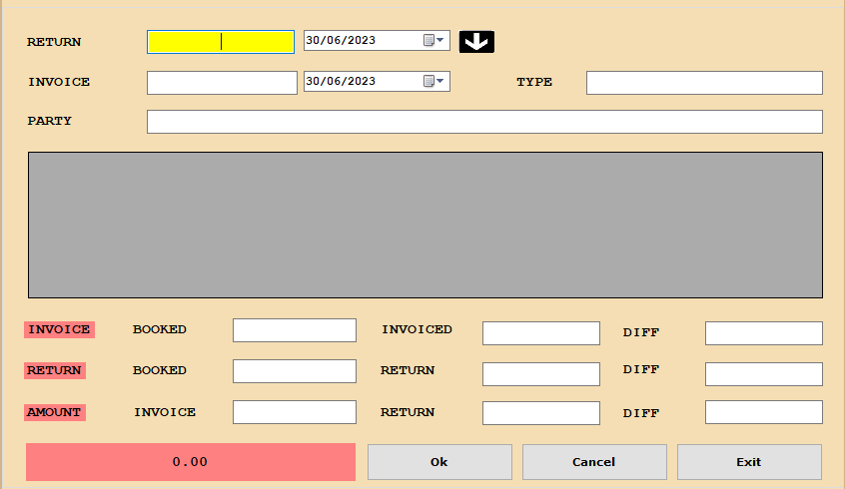
Table Structure:
Table name : Salesreturn_Details
Column Name | Datatype | Constraint
RowID | Identity column | Auto Increment
Return_No | Integer | Primary key
Return_Date | datetime
Invoice_Master_ID | Integer
Gross_Amount | integer
Other_Charges | Integer
Net_Amount | Integer
RO_Amount | Integer
TNet_Amount | Integer
Entry_System | varchar(50) | hostname
Entry_Date | datetime | user time
User_Code | Integer | user system
Company_Code | Integer
Year_Code | Integer
Remarks | varchar(250)
BillPassing_Status | varchar(1)
Approval status | varchar(1)
App_by | varchar(50) | hostname
App_at | datetime | user time
App_on | Integer | user system

