CHITHIRAVARMAN.S
Management Professional
Production | Material Planning | Inventory Management I TPM I TQM I Lean Manufacturing
Oversees and coordinates the activities of the Truck bus radial tyre production line, prepare schedules, resolve issues and ensures adherence to safety and quality standards
Goal-oriented professional offering 14 years of end-to-end Production, Planning & Control, Procurement, Material Planning and Inventory Control expertise that directly results in efficiency improvements & cost savings
chithiravarmans@gmail.com +91-9655961709
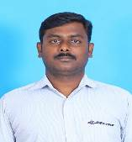
Soft Skills    Change Agent  Motivational Leader  Thinker  Collaborator  Communicator  Planner |  | Profile summary
- Hands-on experience in analysing the prevalent production systems / processes, identifying loopholes, if any and undertaking result-oriented measures for alleviating them and documenting the same
- Creating reports and records of production processes and tools issue performance and inventory; sharing them with managers and providing suggestions to improve safety, productivity and quality
- Gained 2 green field exposure of working on TBR & PCR Curing erection & production.
- Maintaining and updating the documentation related to standard operating procedures and safety and quality standards; ensuring all processes and products meet desired safety and quality standards
- Supervising and directing the daily activities of production line workers, assigning tasks, ensuring their safety and monitoring their performance.
- Onboarding new hires, managing scheduling and work conflicts, monitoring safety, and promoting internal communication to create a culture of collaboration and continuous improvement
- Confirmed with Gold Category Awards in regional & national level Quality Circle Competitions and SMED Projects from Japanese academy.
- Displayed skills in ensuring suppliers meet service, cost, delivery & quality expectations as well as providing outstanding value in product technology and supplier innovation.
- Resourceful in defining & implementing quality standards & structured processes for manufacturing operations in plants
- Accomplished, ambitious & dedicated professional with expertise in providing counselling, training / development, instruction, and consulting
- Conducting internal IATF:16949 audits and monitoring the major NC closure through PDCA and SDCA
- Coordinate with quality team for conducting 8D analysis for the customer complaints and review the documents.
- Approaches problem solving techniques by using DMAIC approach to solve unknown problems
- Makes systematic comparison of two or more solutions for each problem and analyzing the foreseeing probable resistance for each solution.
- Uses flow charts, pareto charts, fishbone diagrams, controls charts, MSA, linear and multiple regression, hypothesis testing to solve out the problem
- Demonstrate the ability to estimate the time and resources by using GANTT Chart

- Applies the concept of continual improvement to identify the opportunities for greater efficiency
- Seek help to implement ideas for process improvement from employees and contract labors
- Discuss the major activities performed by the employees and rewarding
- Conducting on the job training in the shop floor to explain about the basic functions and operations to operators
- List of value and non-value-added activities performed by the operations
- Describes the systems tools and techniques followed by the organization
- Lists common tasks and activities performed by operations functions and sub functions
- Conducts daily preventive maintenance check list and keep tracking safety features in the equipment
- Inspects manufacturing working environment and identifies near miss, unsafe conditions and unsafe act and closes as soon as possible
- Utilizes personal protective equipment required or recommended for the operation carried out by the entire department
- Issues work permits and monitoring the activities carried out by the team
Timeline
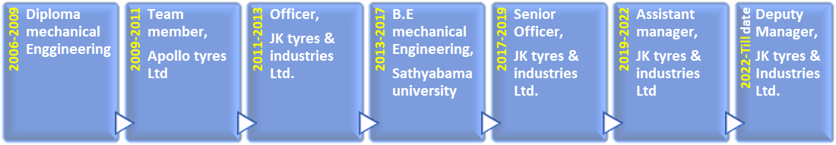
Core Competencies
  Production Planning & Control | Quality Management
  Material Planning | Inventory Management
  Vendor Management | Client Relationship Mangement
  Reporting & Documentation | Team Building & Leadership
Organizational Experience | Since June’20 to till date: JK tyres & Industries ltd pvt ltd, Chennai ,Working as Deputy manager  April’11 – May’19: JK Tyres & Industries ltd,Chennai Plant, as Production Senior officer,TBR Building  June’09 – April’11: Team member Trainee,TBR Building,Production  Key Result Areas:  - Administering the entire production activities which involve product quality improvement through effective process control, waste identification & elimination, workmen training based on skill matrix, and so on  - Coordinating with Machine Supplier for the entire operation of green tyre component assembling process  - Managing facility planning and procurement of required tooling material handling equipment  - Achieving the assigned targets related to production, quality, delivery, safety, cost and morale  - Conducting training programs based on TPM, SIPOC , 5S, LEAN Concepts & QMS Requirements for Diploma Engineers  - Creating all relevant QMS / OHSAS / ENMS documents such as PFC, CP, PFMEA, WI, HIRA, AIA, and so on  - Preparing all shop floor records like Logbook, Start-up Check List, Material ID Tags, Traceability Record, Inventory Records, and so on  - Leading a team of 82+ personnel which include 8 Shift In-charges, and 400+ Operatives  - Hiring operators and training them on soft skills, technical & on-the-job training  Accomplishments:  - Implemented Jishu Hozen Pillar as a Leader for Manager model machine in TPM and been a Co-Ordinator for JH Pillar  - Merit of being member of Identified High Performers (IHP) of JK Tyres by various assessments.  - Confirmed with Gold Category Awards in regional & national level Quality Circle Competitions and SMED Projects  - Recognised for achieving the production targets by improving the machine availability from 82% to 90% in TBR Building.  - Steered efforts in reducing the production cycle time by eliminating minor stoppages from 17 to 8 in TBR Building.
Academic Details | - B.E. (Mechanical Engineering) from Satyabhama university, Chennai-2017  - Diploma mechanical engineering from Tamilnadu polytechnic collage, Madurai.
Certifications | - Certified Lean six sigma Black belt in MSME.  - Certified Internal Auditor from DNV.GL for IATF 16949:2016 in 2017  - Certified Trainer for JH step 4(Bearings)
Trainings | - Attended technical training in Apollo R&D and JK Tyres R&D about Tire Construction and Process-oriented Training  - Attended managerial Excellence from JK tyres  - In-house Training of IATF 16949:2009 Internal Auditor, Statistical Process Control, FMEA, APQP and PPAP
Personal Details | Date of Birth: 06th April 1989  Languages Known: Tamil, English and Hindi  Present Address: Door No.4/335, Gnanapaniditha nagar, Old perungulthur, West Tambaram, Chennai – 600063  Permanent Address: No 14-3-10, west street, Alathuranpatti, Kannivadi, Dindigul – 624705, Tamil Nadu  Passport No.: M1203904 (Valid till 17/08/2024)

