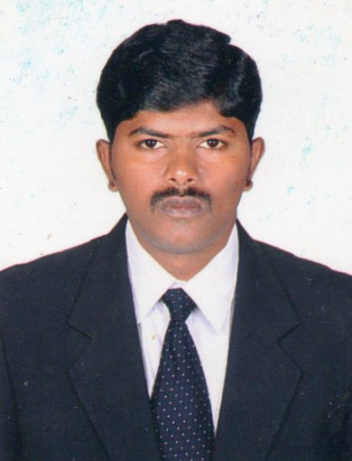
K. SARAVANAN
2/204, Main Road,
Vakkampatti (P.O), Dindigul |Tamil Nadu| India
Mobile: +91-9751069867, Email: saravanan86.k@gmail.com

Career Objective
My career objective is to work in a fast-growing environment where I can utilize my strength and skills and grow along with the concern.

Education Credential
Degree | Institute | Year | Percentage
MCA  B.Com(Computer Application) | J.J. College of Engg. And Tech., Trichy  GTN Arts College, Dindigul | 2010  2012 | 72%  64.6%
Class XII | St.Mary’s Hr Secondary School, Dindigul | 2004 | 71.8%
Class X | St.Mary’s Hr Secondary School, Dindigul | 2002 | 75%
Technical Skills
Languages &Technologies  Packages | C, C++, Java, SAP-ABAP  Ms-Office, Visual Basic
Web Tools | XML, HTML.
Database | My Sql, MS Access

Work Experience
Evora Retail Pvt Ltd -Dindigul Sep 2024 to till date Designation: Senior Executive

Capra Textiles -Dindigul Mar 2023 to Mar 2024 Designation: Asst.HR Manager

Color Dreams (Unit of Sri Saravana Mills Pvt. Ltd.)-Dindigul Dec 2014 to Mar 2023
Designation: Senior Executive HR

Narayanan Construction- Bangalore Jan 2013 to Nov 2014
Designation: Accountant

Axim Infotech Pvt. Ltd- Bangalore Aug 2011 to Oct 2012
Designation: SAP ABAP Developer

PROFESSIONAL SUMMARY

- Monthly Payroll Preparation
- Bonus and full and final settlement
- Timely payments of various bills.
- Monthly Payment of ESI & PF
- Co-ordinate with compliance team Liasioning with ESI, PF, PT, LWF, Labour department, Pollution Control Board officials, and Inspector of Factories, Contract labour act etc
- Coordinating with HR Team and receiving audit certificates required by buyers like GOTS, SEDEX, WRAP, and CTPAT.
- Administering Security, Mess.
- Coordinating with manpower supporting Agents for recruiting new employees from local and other states.
- Administration of welfare measures such as transport, Canteen, rest rooms, lockers, and hotel room reservations for guests etc.
- Staffs travel administration and event Management
- Organizing cultural activities and talent exhibition program.
- Implementing disciplinary standards for minimizing violations of rules & regulations.
- Attending interpersonal issues arising at work place & initiating motivational activities

Core Competencies

- Professional, Growth Oriented, Easy Adaptive and Quick Learner.
- Talented, Independent, Responsible, Hardworking and efficient in analytical complex solving issues.
- An extrovert with very good blending capabilities.
- An absolute team player with good communication skills.
- Ability to deal with a diverse range of cultures and nationalities internationally.
- Highly competent self-motivated, hard-working with the ability to rapidly learn and apply new skills.

Personal Details
Name | K.Saravanan | Languages | Tamil & English
Father’s Name | Kulandai | Date of Birth | 24/07/1986
Sex | Male | Marital Status | Married
Nationality | Indian | Native Place | Dindigul
Age | 35 | Pan Card No | DMHPS2961E
Declaration

I (K.Saravanan) hereby declare that the above information given by me is true to the best of my knowledge.

Place: Dindigul Yours Sincerely,

Date: (K.Saravanan)

