**RESUME**

**PERSONAL DETAILS:**

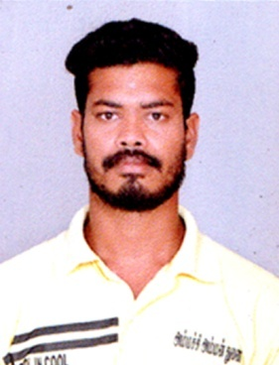**NAME : A.KATHIR PANDI,**

**ADDRESS : S/O. S.ASAITHAMBI,**

**VINNAKUDI KURAVAKUDI (POST),**

**USILAMPATTI (TALUK),**

**MADURAI (DIST), PIN.625 537**

**CONTACT NO: 85250 19579, 7695989324**

**OBJECTIVE:**

To pursue a highly challenging career where I can apply my knowledge to gain new skills and

Contribute sufficiently to the organization.

**ACADEMIC CHRONICLE:**

|  |  |  |  |
| --- | --- | --- | --- |
| **COURSE** | **SCHOOL / COLLEGE** | **YEAR OF PASSING** | **PERCENTAGE** |
| Diploma in Mechanical Engineer | Thiruvalluvar Polytechnic College, Soolapuram | 2017 | 63% |
| HSC | Govt Higher, Sec, School Nattamangalam | 2015 | 52% |
| SSLC | Govt Higher, Sec, School Nattamangalam | 2013 | 59% |

**AREA OF INTEREST SPORTS:**

* Football
* Kabadi

**OPERATING SYSTEM:**

* **Windows 8.1, Windows 07 Windows 10**

**EXPERIENCE:**

* Sri Alamelammal Garments Chekkanurani Maintenance Mechanic in 3 Years

**WORKING MECHINE:**

* D.S/N, S/N, O/L, FB/FL, C/FL, MC/FL, HFL, M/HFL, S/B, B/N, B/T, KAJA , FS

**PERSONAL DETAILS:**

**Name** : A.Kathir Pandi

**Father Name** : S.Asaithambi

**D.O.B** : 10.05.1998

**Age** : 27 years

**Gender** : male

**National** : Indian

**Marital Status** : Married

**Languages Known** : Tamil & English

**DECLARATION:**

I hereby declare that the above-mentioned information is correct up to my knowledge and I bear the responsibility for the correctness of the above-mentioned particulars.

**SIGNATURE**

**PLACE**:

**DATE:**  **(A.KATHIR PANDI)**