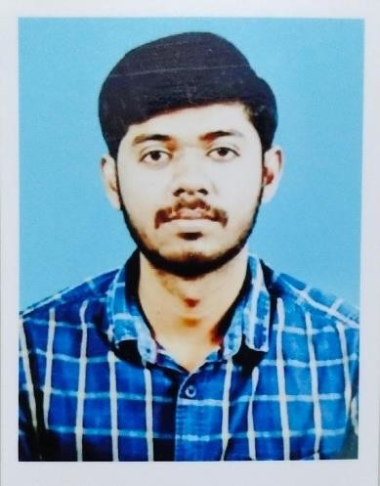Resume

*Aravind.k*

Door no 447/140, Sathiyamoorthi road ARNI (tk)**–** 632 301,

Tiruvannamalai (DT). Tamil NADU

Mobile: (+) 91-7200691550

[Email aravindkarthic123@gmail.com](mailto:aravindkarthic123@gmail.com)

Dear Sir,

I am a young diligent production manager & Industrial Engineer looking for a suitable placement in your esteemed organization and am confident of doing good work.

I successfully completed my DIPLOMO course in the year 2013 with an outcome of 73% marks. I have Ten year plus experienced in Various company.

Please find attached, my Curriculum Vitae for your kind perusal. If required, I will be happy to

furnish any additional details.

I am looking forward to a favorable reply.

Thanking you,

Yours truly, Aravind.K

Objective

A young qualified Engineer, seeking a challenging and competitive environment that would facilitate transformation of my best ability to the entire satisfaction of the company and me, to reach higher and productive goals.

**Educational Qualifications**

May 2013 : Diplomo in textile technology

Institute of textile technology, Tharamani ( Chennai ) [Tamilnadu State Board]

DIPLOMO (Textile Technology) [with Aggregate of 73%]

March 2011 : Government Higher Secondary School,onnupuram - Arni [Tamilnadu State Board]

Higher Secondary Certificate (H.S.C) [with aggregate of 71%]

March 2009 : Subramanya shastri Higher Secondary School, Arni. [Tamilnadan State Board]

S.S.L.C [with aggregate of 65%]

# Working Experience

I have three years (May 2013 to Jan 2016 ) plus experience as Industrial engineer in Stanfab apparels private limited at Chennai

I have two years (Jan 2016 to Nov 2018 ) experienced as Industrial engineer in Penguin apparels private limited at Madurai

I have Six month (D e c 2018 to April 2019 ) experienced as Industrial engineering Manager in Asian fabric private limited at Karur

I have One Year and Six months (May 2019 to Nov 2020 ) experienced as Industrial engineer in Magnum Clothing Private limited at Kanchipuram.

## I have Eight Months (Dec 2020 to AUG 2021) experienced as Production in charge in Natchi Apparel (P) Ltd (Eastman Group of Companies).

I have three years ( SEP 2021 to T i l l D a t e ) experienced as Factory manager & Industrial engineer in Penguin apparels private limited at Madurai .

# Responsibilities

## Ensure Grading of operators based on the fundamental rules fixed by the organization.

Operation breakdown and Thread consumption.

## Implement and follow up the Kaizen.

SAM calculation.

Fixing daily production target based on line capacity.

Follow the factory WIP and ensuring Order Completion as per schedule. Ensure Macro and Micro level line balancing to achieve maximum output. Calculate and organize the machinery requirements as per line plan.

Skill matrix development in each operator and line.

Monitor and review hourly production and bottleneck operations take necessary steps to improve capacity.

Experience in Tops and bottom and for both Men’s and Women’s. & home textile. Production Planning and checkout requirement of trims.

I have handled 340 M/C and Cut to Pack.

Project the Manpower requirement for every three months to HR keeping mind the absenteeism.

**Products handling:**

Shirts, Shorts, Pants, Outer wear Jackets (Woven & Quilted), Cover all, Raincoat, T Shirts, Inner wears, leggings, Home Textile Products.

# Personal Details

Name : Aravind.K

Date of Birth : 28 APRIL 1993

Gender : Male Marital

status : Married

Nationality : Indian

Father’s Name : Mr. J.N.KARTHIKEYAN Language expertise : English & Tamil & Sowrasthra

Address for Communication : Door no: 447/140 sathiya moorhi Road,

Arni (tk) – 632301, Thiruvannamalai (DT). Tamil NADU

Declaration

I hereby declare, all the above mentioned information is correct to best of my knowledge. Looking forward for a long term association with your company.

Place: yours truly

Date: (Aravind.K)