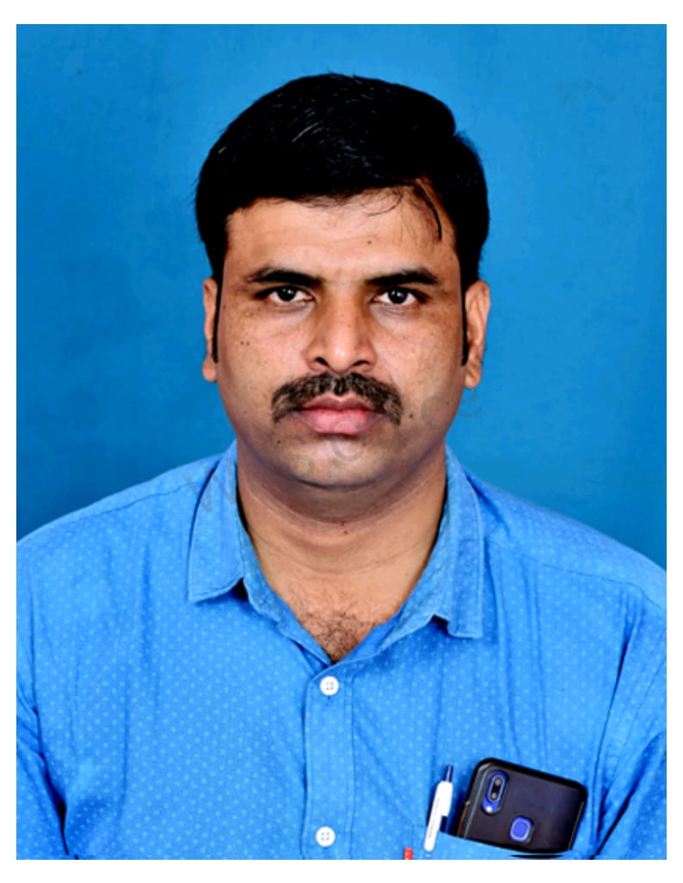
CURRICULUM VITAE
S.RENUGOPAL
ARIGAVARIPALLI [V]
D.P PALAUAM [P]
GUDIYATHAM [TK]
VELLORE [DT]
cell no : 9751493019
mail id : s.renugopalnaidu.ntr@gmail .com

AREAS OF EXPERTISE:
Team building & supervision, Time management, Operational process analysis, Productivity & efficiency improvement, Forecasting, on time Delivery, Strategic Planning & Implementation, Inventory Control Technical and core Competencies: Ensuring customer satisfaction levels are maintained through quality service practices., Encourage team spirit & build team to achieve organization Goals & targets., Achieving: o Less scarp, rework & inventory. o Better on time production., Timely deliveries., Satisfied to meet quality standards as per customers’ requirements, excellent skills in Setting up the factory and upgrading quality level and minimizing the rejection and re-screen percentage

Profile:
An effective & Successful Plant head , AGM, Factory Manager having over 21 years of experience in managing & solving production issues & achieving the target (Woven & Knitted) industries.

Project Handled
- Manufacturing process Cost Reduction the Factory & Wastage Control
- Successfully implemented Lean Systems and reduced Non-Value Items.
- Set up a new plant of 650 Machines from Sew to Pack operations.
- New Factory set up can be handles within 3 months can be improved 45% of Effeciency.
- Achieved 65% to 70% of Efficiency in sewing lines.
- Successfully implemented “5S & Kanban systems”
- Successfully implemented Self Trimming in the Batch
- Reduction of Rework and rejects along with QA team.

Key Role
- Manage work Force of 900 Machines & Achieve High efficiencies with high profit for the factory.
- Manufacturing process cost control and Wastage Control
- Optimally utilize recourses- Manpower/Materials/Machinery/Space, etc.
- Strengths and practical knowledge of efficiency improvement concepts like Lean, Six Sigma
Job Responsible
- Business growth and profitability of the unit by interacting with customer, vendors, employees.
- Ensure 100% on-time shipment with highest quality.
- Responsible for entire Operations of unit right from fabric in-house to shipments.
- Monitoring & reviewing Factory performance in terms of Production efficiency, quality, factory cost & shipments-periodically.
- Reviewing & controlling factory cost by minimizing manpower, overtime, power & Fuel and Overhead expenses.
- Reviewing style wise Cutting, Loading, Sewing and packing Figures on daily basis and ensuring shipments as per plan.
- Customer complaints if any and ensuring appropriate preventive actions.
- Creating overall awareness among team members and customer expectations and requirements
- Communicate always with merchandising team and solve every production related issue involved merchandising.
- Optimize production processes by implementing Lean manufacturing, Six Sigma relevant techniques to reduce waste and improve productivity.
- Work for 100% capacity utilization and waste reduction.
- Strictly follow up hourly production and work for increasing.
- Achieve High efficiency with high profit for the factory.

Work Experience:
- Current Work Experience : RORAL GARMENTS in kenya, from Jan 2022 to t25-01-2025 plant head ( (Woven) knits, denim.

- Previous Work Experience: Gainup industries in dindugal, from 1 jan 2020 to nov 2021 “Assistant General Manager (Woven & Knits)

- Previous Work Experience: Arvind fashion ltd, in Ethiopia from jan 2019 to dec 2019 “Factory Manager (Woven knits denim)

- Previous Work Experience: ) wonder blue in Bangalore from Jan 2012 to Feb 2019 as “production manager” ( denim, knits,)

- Previous Work Experience: Suryalakshmi cotton mills [ Garmentdivision] from jun 2004 to Dec 20112 as from sampling to APM (denim )

Buyers Handled
NEXT SOURCING LTD, MOTHER CARE, MAX, CAREFOUR, WALMART,
MOP, Camel Active, H&M, Mustang, Lerros, Calvin Klein, J.C Penney (U. S),
Wal-Mart (U. S) M & S, S.Oliver (Germany), Esprit, Puma, Reliance, Tiber, Mother care, 7 shades, Samjho, Rare Rabbit, Mufti.

Product Handled
Denim : 5pkt jean, jacket, romper, designer wears
Shirts, Bottom, Frocks & Part wear, Ladies Top (Woven)
T- Shirts & Body suit. Romper, sleep suit & Kids wear (Knits)

EDUCATION QUALIFICATIONS
 | Degree | Institute
1.  2. | NIFT-TEA knitwear fashion institute,  BSC. MATHEMATICS, Thiruvalluvar University, [UG] | Apparel skill cum technology program [ fiber to garment ] – Tirupur - 6  Gudiyatham,

PERSONAL PROFILE:
Name : S.RENUGOPAL
Date of Birth/Age : 15th may 1984, 40 years
Languages known : English, Hindi, Telugu, Kannada & Tamil
Sex/Nationality : Male/ Indian

