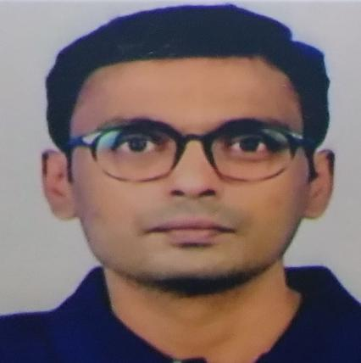 |  | RAJASEKARAN.K
Profile  Professionally well qualified and experienced in Apparel Industry with 20+ years all over work experience in Quality assurance in garment industry for variety of buyers and products including knit, woven and denims. Holding both buying house and factory experience in India and several foreign regions.  Thorough knowledge and experience in several products for well-reputed international and local brands  Contact  Mobile / WhatsApp  +91- 9731796987  EMAIL:  rajasekarank1978@gmail.com / flutterera2k@yahoo.com |  | * PROFESSIONAL QUALIFICATION  - Diploma in Textile Technology, 1999 Sri Sowdambika Polytechnic, Board of Technical Education, Govt. of Tamil Nadu, India.  (GOLD MEDALIST)  Precitex Award for best student in spinning technology  Done the Project to improve the yarn quality.  - Diploma in Apparel Manufacturing Technology, 2002  Apparel training & Design center, ATDC- Chennai,’ India  Process analysis in Apparel manufacturing, Merchandising and Quality Assurance.  “A” Grade  - PVH Certified Auditor  * WORK EXPERIENCE  Employment Record: (Total Experience: 20+ Years)  - QA Manager - Penguin Apparels pvt ltd, Madurai, Tamil Nadu, India (handling Unit 1,2,3,4 and Peacock Unit 2)-  UNI QLO brand and CWF - (From 5th Dec 2024 – July 2025)  - Country Manager – Quality Assurance- Catalyst creative group, USA (Buying House) Bangladesh – (From 14th April 2021 to 31st March 2024)  - Brand QA Manager (PVH) – Shahi Exports Pvt Ltd. Bangalore, India (From 15th Dec 2014 – 16thSep 2019)  - QA Head-Knit division – MUFTI .M/s Credo brands marketing pvt. ltd, Mumbai, India (Buying House) --(From 23rd Mar 2011 to 10th Dec 2014)  - QA In-charge M/s Grove Industry Madagascar S.A.R.L, Madagascar. (From Sep 2009 - Mar 2011)  - Senior Quality Assurance Executive (Buying house)  M/s Atlast Sportswear Inc- Bengaluru, India (USA  based buying office- shahi group of companies,  India – handling Bangladesh/Sri Lanka  Regions - (from July 2006 – Jan 2009)  7.Quality Assurance Executive - M/s P S Apparels Private  Limited (UNIT III) - Chennai. (From July 2002- June  2006)  Key Responsibilities and Accountabilities held:  Good in GMP and Team Building.  Independently handling & heading the quality team of the factory or buying house.  The thorough knowledge of AQL systems  Establishing quality systems and processes in the factory.  Ensure product quality compliance for international buyers.  Assuring in-house and outside product quality from production start to final shipment  Quality control of Dry and Wet process of denim washing.  Analyzing department workflow and making staffing and category assignment recommendations  Ensure garment quality as per quality parameters & Buyer’s direction.  Identify causes and suggest actionable steps to improve product quality and reduce numbers of returns and repairs of products  Monitoring the implemented QA procedures of the factory and further Development & Improvement of QA procedures of the factory  Working for the implementation of six sigma as a Coordinator.  Handled up to 10000 machines and more than seven plants.  Deal with the buyers independently for all quality assurance activities including quality control / audit, sample quality, PP meeting, In line inspection, Midline, pre-final and final inspection  Brands handled:  UNIQLO, CWF, IZOD, CK jeans, Mufti, American Eagle, A & F, Levis, Dockers, POLO Ralph Lauren, Kohl’s, Target, Wall Mart, Sam’s club, Tilly’s, GAP, Nike, GV, Stani, True Blue, Ruf & Tuf , PRYM, Shuffle etc.  Products handled:  Capable of handling woven, knits and Denim products.  Woven bottoms and jackets, Men’s and Ladies shirts and denims, Casual and Formal pants, women’s tops, full dress, sweater, Kids wear, track suits, sportswear, T shirts, Formal shirts, Blazer, Bandi, etc. (Both wash and Non wash products)  Languages  English - Fluent  Tamil - Native fluency  Kannada- Good  Computer Literacy  MS Office, Windows  Personal Details  Full name - Rajasekaran Kannan  Age - 46  Gendnon - Male  Nationality - Indian  Marital status - Married  Passport - U8986605  Email - rajasekarank1978@gmail.com /flutterera2k@yahoo.com  Mobile no - +91- 9731796987  I hereby do declare that the above information given is true and correct for the best of my knowledge.  Thanks,  Sincerely,  Rajasekaran K DATE

