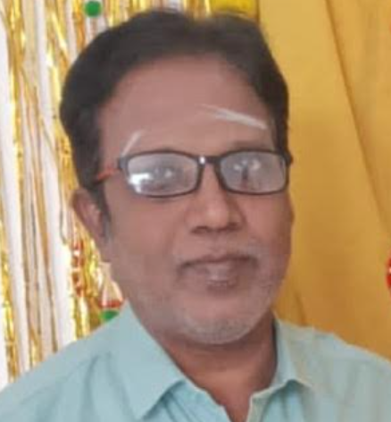

P. Manikandan,

4/286, Main Road

NGGO Colony

Coimbatore – 641022

Mobile No : 9500063304
Email : maniyagnya@gmail.com
CAREER OBJECTIVE:
To work with my potential and deliver my best to the company. Seeking association with a progressive organization that gives me scope to update my knowledge and skills and be part of a team that dynamically works for the growth of the organization.
Professional Experience: 32 years

Worked at M/s. Fresco NY (P) Ltd., Buying House as a DGM Merchandising &
Marketing

AROUND 7 yrs EXPERIENCE in M/S Magnum Clothing Pvt Ltd., Chennai, India
Senior Divisional Merchandising Manager from April 2018 to 2025 Feb 1st
- AROUND 25 yrs EXPERIENCE in M/S Tulip Clothing Pvt Ltd., Tirupur, India
- General Manager - from 2010 – 2018 April
- Merchandising Manager - from 2008 – 2010
- Senior Merchandiser - from 2004 - 2008.
- Merchandiser - from 1998 - 2004.
- Junior Merchandiser - from 1993 - 1998.

Buyers Handled

- ANN TAYLOR - USA
- C&A - Germany/France/Netherland/Slovakia/Turkey/Belgium/Switcher land
- Tesco – UK
- TK Max – UK
- BHS – UK
- Sainsbury – UK
- Dorothy Perkins – UK
- Stubbies Clothing Company (Pacific Dunlop) – Australia
- Gymboree Corporation Ltd – USA
- Winners – USA
- TJ Max – USA
- NEXT UK
- Sargent Major, France
- DPAM, France,
- Daniel Sportswear, USA
- Retour, Netherlands
- Shop Direct – UK
- Best Seller – Domastic
- Best Seller - Denmark
- Kroger – USA
- Northern Reflection – Canada
- Original Marine – Italy
- Woolworths – South Africa
- Matalan UK
- Joules UK
- Cecil Germany
- Street One Germany
- Tom Tailor Germany
- S Oliver Germany
- Far A Field Portugal
- LOP Portugal
- DECENIO Portugal
- GIOVANNI GALLI Portugal
- Devred, France
- Guess, Europe
- Beverly Hill Polo Club, USA
- Scalpers
- Shilton
- Jules
- Salsa
- Maje
- Florentino
- MAAG, Dubai
- Cala
- Ragtex
- WAM
- Land Mark
- Tailorbyrd, USA
- Rain Forest, USA
- Champion, USA
- BAK Apparels, USA

Countries visited for Marketing

- USA – San Francisco & New York
- Hong Kong
- Belgium
- France – Paris

HIGHLIGHTS OF QUALIFICATION:
- Good Interpersonal Skills
- Good Leadership Qualities
- Maintain good Interaction with others

Educational Qualification:

- M.Sc Mathematics
Madras University

Computer Proficiency:

- MS Office & Outlook Express
- Internet Functions
- ERP Packages

Personal Details:

Father’s Name: Panchapakesan.A

Date of Birth: 18th-November-1973

Sex: Male

Nationality: Indian

Marital Status: Married

Age: 51

Languages known: Tamil & English

Notice period: ONE Month

Drawn Salary : INR 192000 CTC

Declaration:

I do here by declare that particulars of information and facts stated herein above are true, correct and complete to the best of my knowledge and belief.

PLACE: COIMBATORE Signature

DATE: MANIKANDAN P

