**ERP Requirement Template**

**TNO : GSA0116**

**USER NAME : M.MURUGAPANDI**

**PROCESS FLOW :**

**MODULE NAME : V BILL**

**COMPONENT NAME : SALES INVOICE**

**MENU LINK**

Transaction 🡪 YARN – SALES INVOICE

**SCREEN**

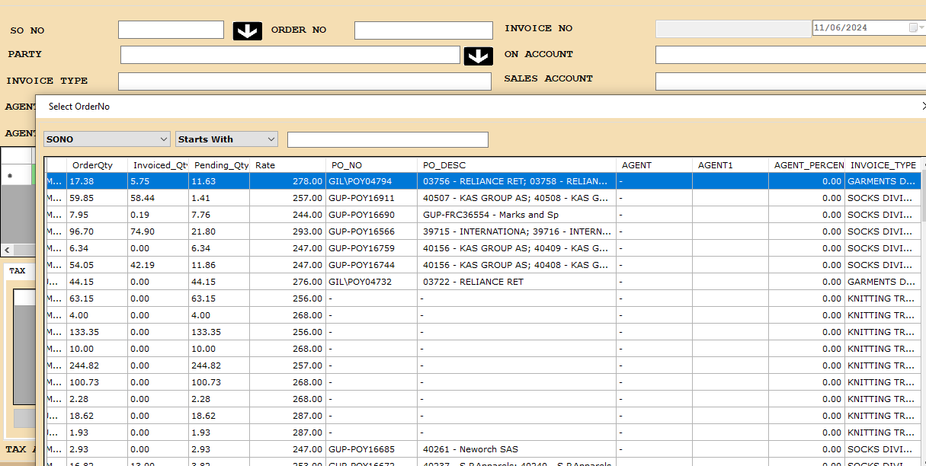

**DESCRIPTION:**

1. in cancel New option I Yarn Sales invoice Screen, highlight the Shipped OCNs based on OCN/PO.

**JOURNAL ENTRY (IF APPLIED):NA**

|  |  |  |  |
| --- | --- | --- | --- |
|  |  |  |  |
|  |  |  |  |
|  |  |  |  |
|  |  |  |  |
|  |  |  |  |

**NARRATION (IF APPLIED):**

NA

**APPROVAL SCREEN REQUIRED**

NO

APPROVED BY:

NA

**APPROVAL MENU LINK:**

**NA**

**REPORT REQUIRED?**

YES

**TYPE OF REPORT:**

GRID REPORT

**REPORT FORMAT:**



REMARKS:

|  |
| --- |
|  |