**ERP Requirement Template**

**TNO : GHA0001**

**USER NAME : SELVAKUMARESAN S**

**PROCESS FLOW : HEADWEAR**

**MODULE NAME : HEADWEAR**

**COMPONENT NAME : SAMPLE**

**MENU LINK**

HEADWEAR – TRANSACTION – GRN – PROCESS GRN

**SCREEN**

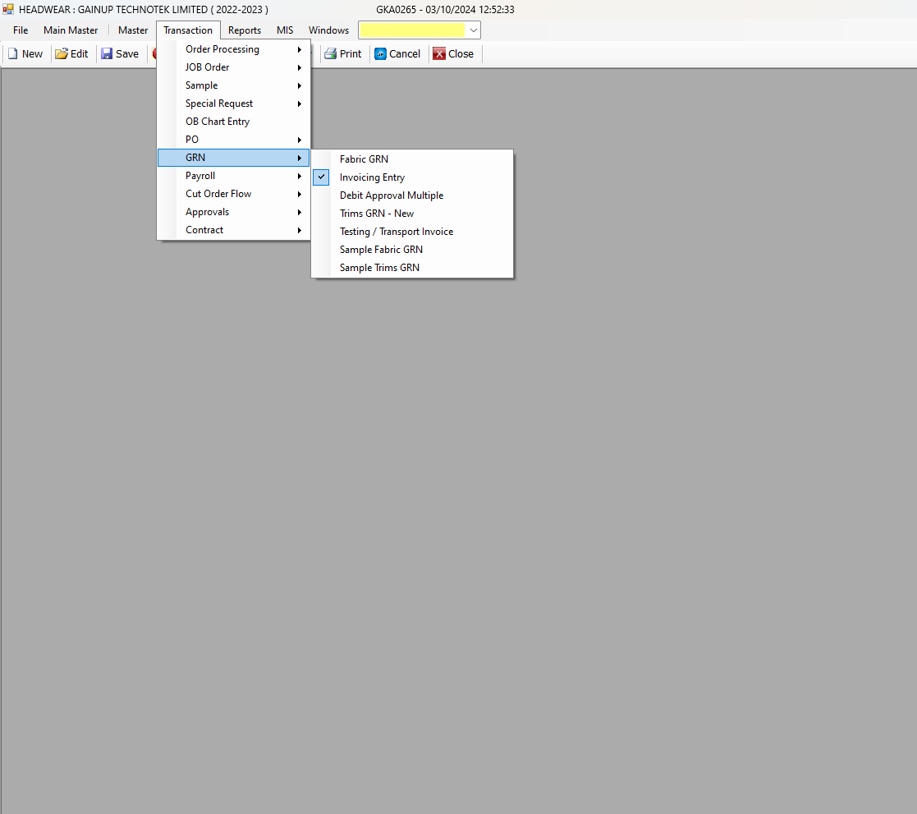

**DESCRIPTION:**

1.

2.

3.

4.

5.

**CONDITIONS:**

1.

2.

3.

4.

5.

**JOURNAL ENTRY (IF APPLIED):**

|  |  |  |  |
| --- | --- | --- | --- |
|  |  |  |  |
|  |  |  |  |
|  |  |  |  |
|  |  |  |  |
|  |  |  |  |

**NARRATION (IF APPLIED):**

**APPROVAL SCREEN REQUIRED?**

YES

NO

APPROVED BY:

**APPROVAL MENU LINK:**

**REPORT REQUIRED?**

YES

NO

**TYPE OF REPORT:**

MIS

POWER BI

GRID REPORT

CRYSTAL REPORT

LIFE@GAINUP

**REPORT FORMAT:**

|  |  |  |  |  |  |  |  |  |
| --- | --- | --- | --- | --- | --- | --- | --- | --- |
|  |  |  |  |  |  |  |  |  |
|  |  |  |  |  |  |  |  |  |
|  |  |  |  |  |  |  |  |  |

REMARKS:

|  |
| --- |
|  |