ERP Requirement Template
TNO : GHA0001
USER NAME :GHA0012
PROCESS FLOW :INCENTIVE REPORT
MODULE NAME :WOVEN ERP
COMPONENT NAME :
MENU LINK
Reports – combined data

SCREEN

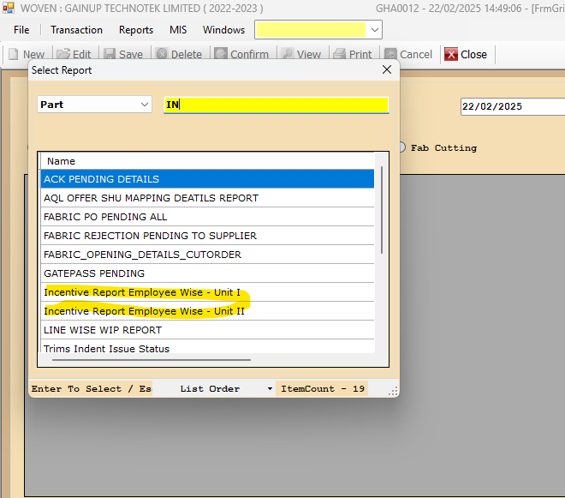

DESCRIPTION:
1. EMPLOYEE WISE INCENTIVE REPORT REQUIREMENTS
2.
3.
4.
5.

CONDITIONS:
1.
2.
3.
4.
5.
JOURNAL ENTRY (IF APPLIED):
NARRATION (IF APPLIED):

APPROVAL SCREEN REQUIRED?
YES
NO
APPROVED BY:

APPROVAL MENU LINK:

REPORT REQUIRED?
YES
NO
TYPE OF REPORT:
MIS
POWER BI
GRID REPORT
CRYSTAL REPORT
LIFE@GAINUP

REPORT FORMAT:

REMARKS:

