**ERP Requirement Template**

**TNO : GKA0335**

**USERNAME : GKA0335**

**PROCESS FLOW : Service bill entry and MD approval move to accounts module**

**MODULE NAME : VMS**

**COMPONENT NAME : SERVICE**

**MENU LINK – Life@gainup**

**SCREEN**

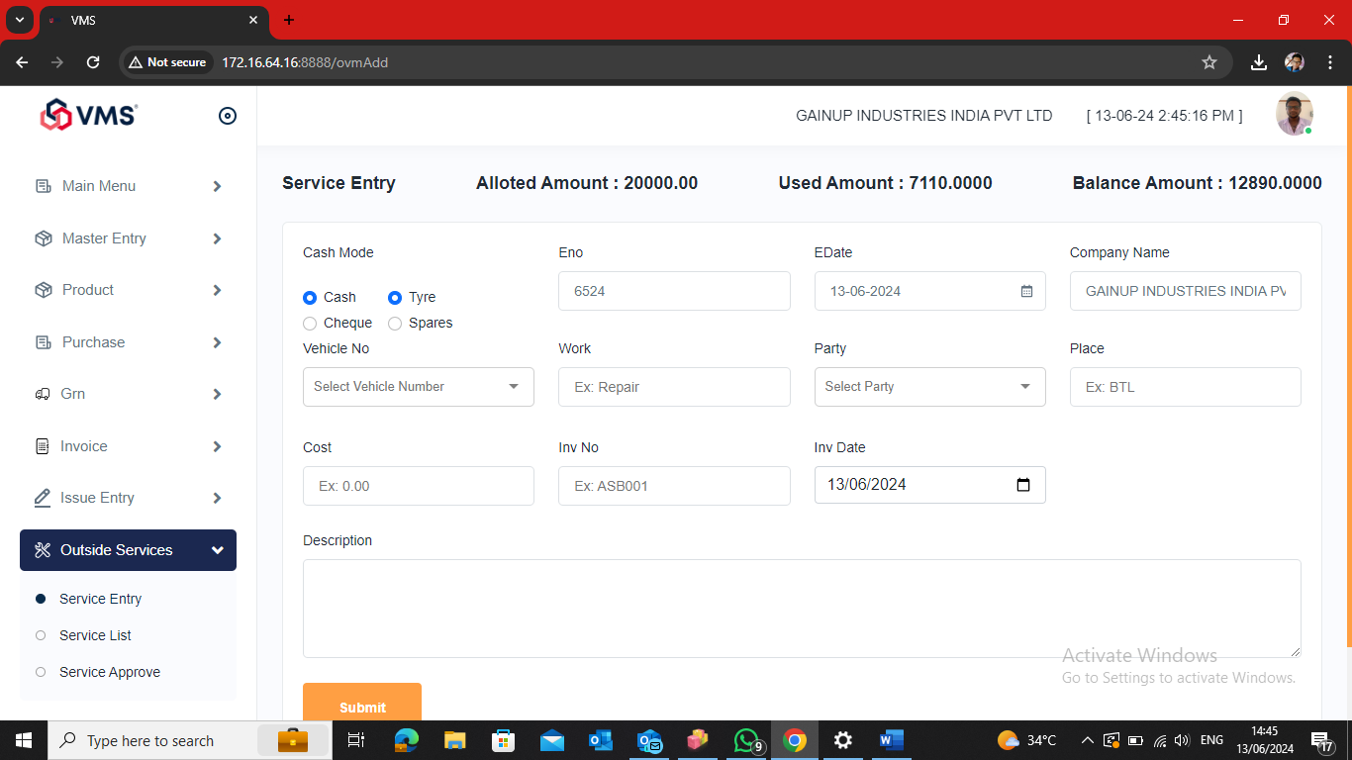

**DESCRIPTION:**

1.

2.

3.

4.

5.

**CONDITIONS:**

1.

2.

3.

4.

5.

**JOURNAL ENTRY (IF APPLIED):**

|  |  |  |  |
| --- | --- | --- | --- |
|  |  |  |  |
|  |  |  |  |
|  |  |  |  |
|  |  |  |  |
|  |  |  |  |

**NARRATION (IF APPLIED):**

**APPROVAL SCREEN REQUIRED?**

YES

NO

APPROVED BY: MD

**APPROVAL MENU LINK:**

**REPORT REQUIRED?**

YES ++++++++

NO

**TYPE OF REPORT:**

MIS

POWER BI

GRID REPORT

CRYSTAL REPORT

LIFE@GAINUP +++++++++++

**REPORT FORMAT:**

|  |  |  |  |  |  |  |  |  |
| --- | --- | --- | --- | --- | --- | --- | --- | --- |
|  |  |  |  |  |  |  |  |  |
|  |  |  |  |  |  |  |  |  |
|  |  |  |  |  |  |  |  |  |

REMARKS:

|  |
| --- |
|  |