Trims Sales Technical Flow -Woven

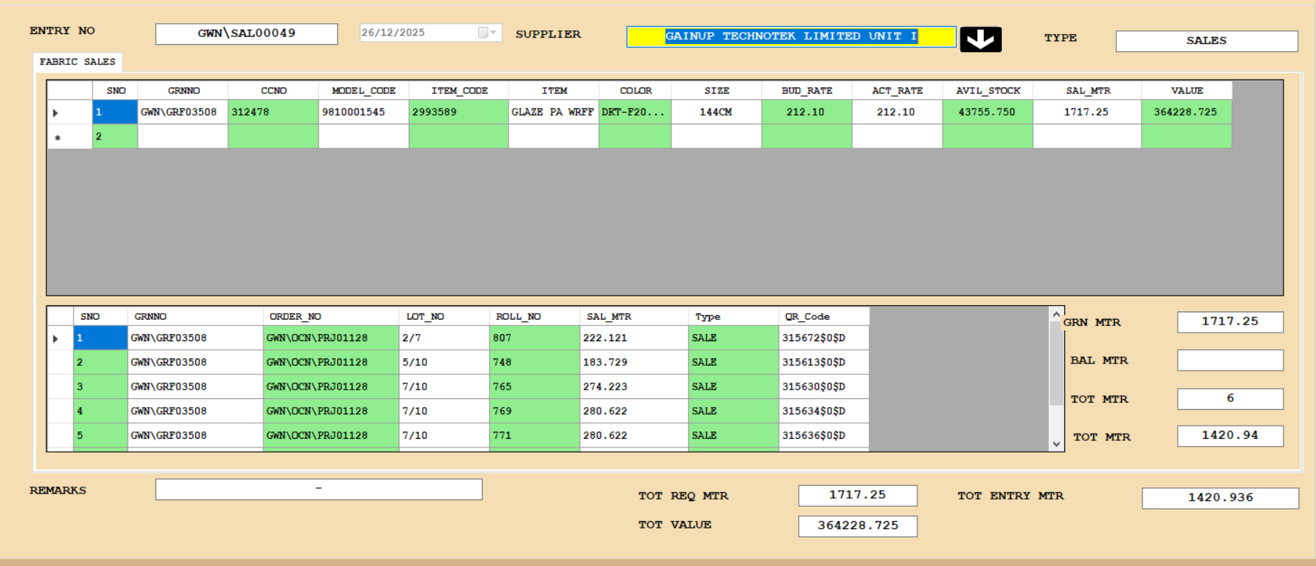

- The Fabric Sales Request Entry screen should be the same as the Trims Sales Request Entry screen. One small change: Fabric selection should be roll-wise, whereas Trims Sales uses cumulative stock selection based on Item Code and Model Code.
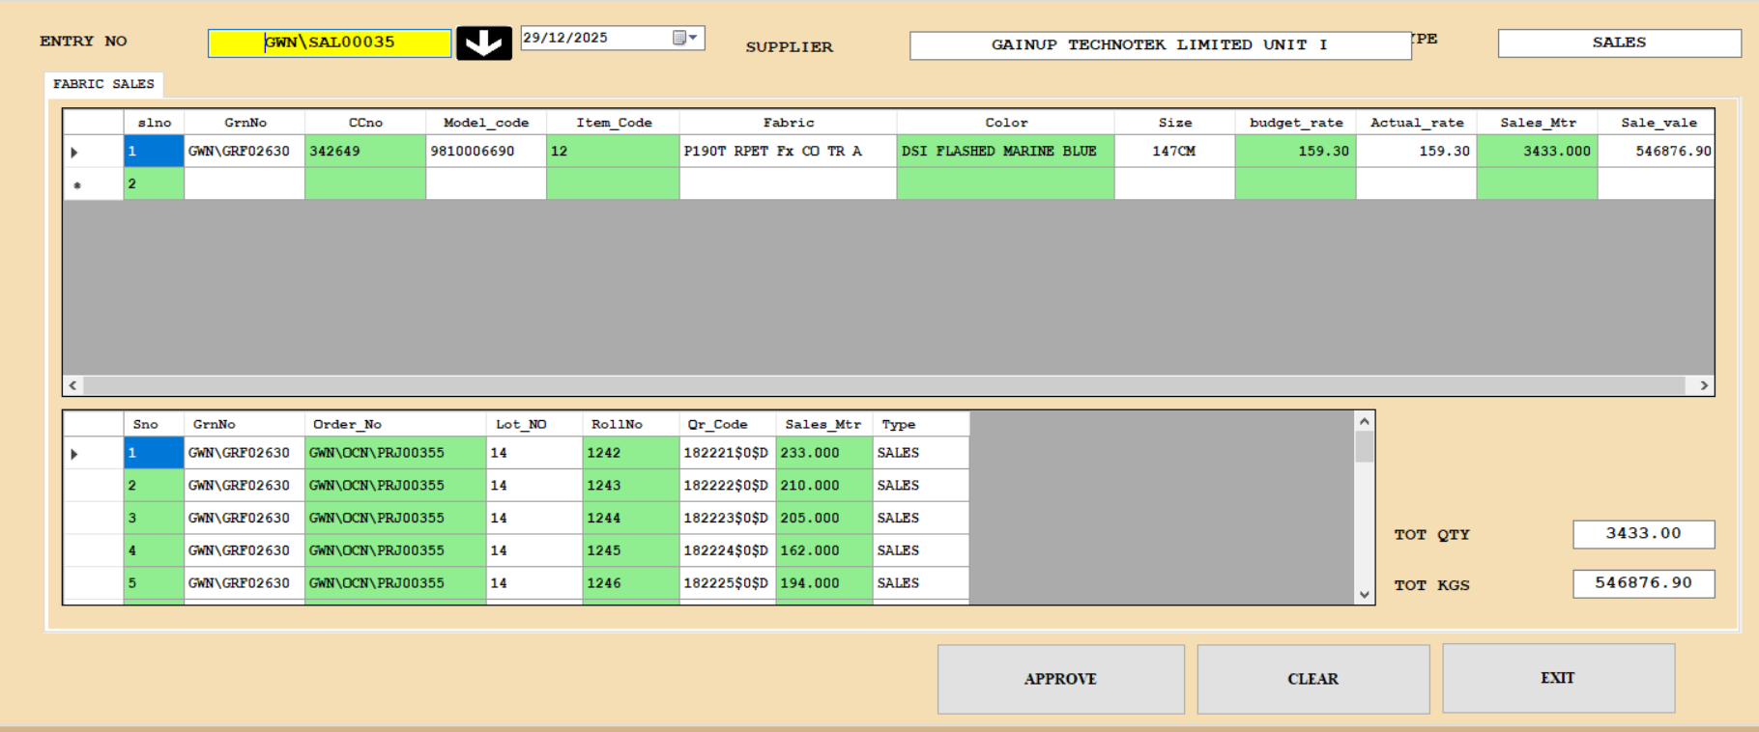

- The Fabric Sales Request Entry – First Level Approval screen should be the same as the Trims Sales Request – First-Level Approval screen
- The Fabric Sales Request Entry – Second Level Approval screen should be the same as the Trims Sales Request – Second -Level Approval screen.
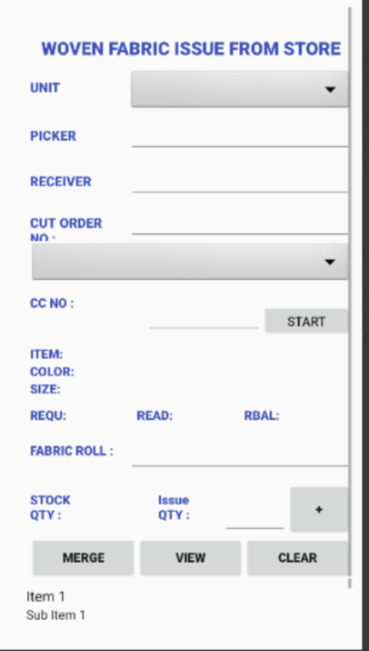
- Once the two-level approval is completed, allow scanning against the Request Entry No.
During scanning, the Trims QR code must be mapped to the location.
While saving the Sales Entry, the system should check whether the Model Code and Item Code match the Request Entry.
If not, show an error message:
“Kindly check the Model Code and Item Code.”
- Stock Reduced for Mapping Table (Vstore_Opening_Stock_Box_Details)
Existing Screen and Report Changes.
- Add Sales Quantity and Sales Value columns to the All-Trims Report
- Add Sales Quantity in the Stock Check and Valuation function and procedure
(Example: In the Cut Order screen, Trims Stock Check should consider Sales Quantity.)
- Update the existing Bill Pass function to include Sales Trims Indent details
Table structure:
QR Details Table:
Vstore_Opening_Stock_Master
Vstore_Opening_Stock_Box_Details
Indent Request Table structure:
- Create a new table like the Sewing Trims Requirement table.
(Ex: Sewing_Trims_Req_Qty_Vstores_TblUpdate the Two-Level Approval flag in this table for the same Entry No.

Commitment date:
Starting Date : 02/01/2026 End Date: 8/01/2026

