Woven Short Qty QR Code Generation- Technical flow

Conveyor Process screen:
- After box scanning, the system checks the remaining PCB quantity. If the article balance is equal to or less than the allowed quantity, the QR code is generated; otherwise, an error “Delivery balance not available” is show.

- Allow only one model in a box. Show an error message if models are mixed.

QR code details table structure:

1) Create new tables like gloves_packing_fgs_master and gloves_packing_fgs_details

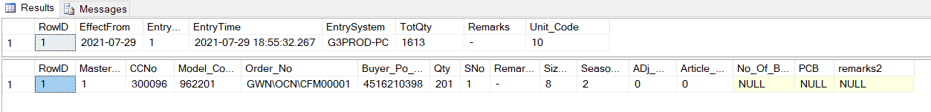

- Once a sorted QR is generated, full box scanning for that article is not allowed.
A message will show that sorted quantity is already available, so a new QR cannot be generated
- Already Avail One Short qty in the Next short Qty Not Allowed.
Mapping Process:

- Create New Screen for Short Qty Mapping Process for short qty pallet.
- Create a new table based on the existing Full Box Pallet Mapping structure.
(ex: existing table structure)

- Create a new mobile app screen for location mapping of short quantity

Sort Qty Issue Return from Packing team:
- Create new Mob App for Issue return packing team.
- Then, after the return entry is approved by the GM, add it to the delivery balance
- Once the issue entry is approved, update the QR entry in the table, set the ‘Return to Issue’ column to ‘Y’, and update the RFID by adding ‘-C.
Reports:
Add a new report for Short Quantity.

Need To Be Developing the Screen:
- Conveyor 3 screens – windows
- 3 screens for Mob App (3 MIS Screen)
- Approve screen from windows

Existing Screen and Report Changes:
- While scanning a full box, if the RFID or article is already available in a sort-quantity box, show an error message:
“This article is already available in the short quantity for this pallet number and location.”
- While checking the existing delivery balance, add the short quantity
- Add a new Short Qty column to the existing All report.

Starting Date : 01/01/2026 End Date: 10/01/2026

