HW – Grade Employee Screen Update
This is available in the Gloves Grade Video Upload screen. The same is required for Headwear.
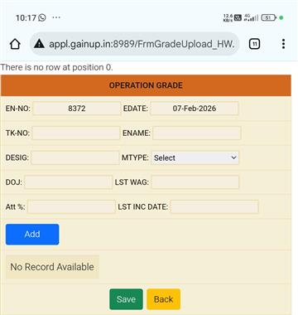

Adding Columns for the HW Screen:
- Date of Joining
- Last Increment Date
- Last 3 Months Attendance %
- Last Wages
Modify Existing Function:
Headwear_Grade_Empl_Details_Fn()

