**ERP Requirement Template**

**TNO : GGA0489**

**USER NAME : VENKATESWARAN**

**PROCESS FLOW : BANK IMPORT**

**MODULE NAME : ACCOUNTS**

**COMPONENT NAME : BRS IMPORT**

**MENU LINK: BRS IMPORT**

**SCREEN**

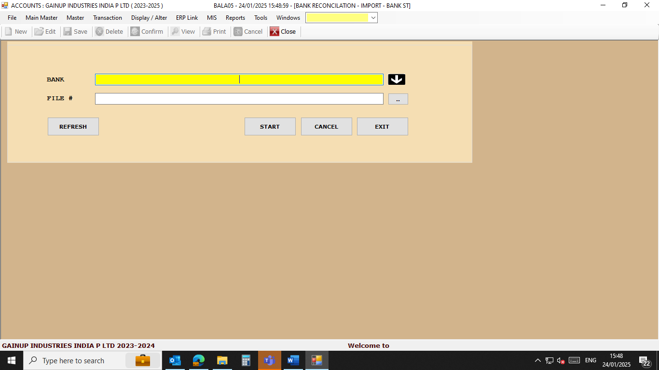

**DESCRIPTION:**

1. We need to upload bank statements to ERP which is downloaded from bank site without editing.

2. We need to upload SBI, HDFC , CANARA, and Axis

3.

4.

5.

**CONDITIONS:**

1. Bank BRS to be done.

2.

3.

4.

5.

**JOURNAL ENTRY (IF APPLIED):**

|  |  |  |  |
| --- | --- | --- | --- |
|  |  |  |  |
|  |  |  |  |
|  |  |  |  |
|  |  |  |  |
|  |  |  |  |

**NARRATION (IF APPLIED):**

**APPROVAL SCREEN REQUIRED?**

YES

* NO

APPROVED BY:

**APPROVAL MENU LINK:**

**REPORT REQUIRED?**

YES

* NO

**TYPE OF REPORT:**

MIS

POWER BI

GRID REPORT

CRYSTAL REPORT

LIFE@GAINUP

**REPORT FORMAT:**

**SBI**

|  |  |  |  |  |  |  |  |
| --- | --- | --- | --- | --- | --- | --- | --- |
| Txn Date | Value Date | Description | Ref No./Cheque No. | Branch Code | Debit | Credit | Balance |
| 23/01/2025 | 23/01/2025 | TO CLEARING-Chq No. 669256 TMB K BALAGURU NADAR--669256 | / 669256 | 10395 | 32295 |  | ######## |
| 23/01/2025 | 23/01/2025 | BY TRANSFER-INB-- | CT00MLTUN6 TRANSFER FROM 39104663611 GAINUP INDUSTRIES INDI / | 99922 |  | 1900000 | ######## |
| 23/01/2025 | 23/01/2025 | TO CLG CHQ-Chq No. 642107 HDF TO CLEARING CHEQUE--642107 | / 642107 | 4034 | 454503.3 |  | ######## |

REMARKS:

|  |
| --- |
| All bank statement with share in mail |