ERP Requirement Template
TNO : GGA0542
USER NAME : SUNDARESAN.P
PROCESS FLOW : PURPOUSE OF SALES ORDER PROCESSING
MODULE NAME : Payroll
COMPONENT NAME : RECEIPTS SALES ENTRY
MENU LINK Tansaction – sock and garments – Receipts Charges order

SCREEN

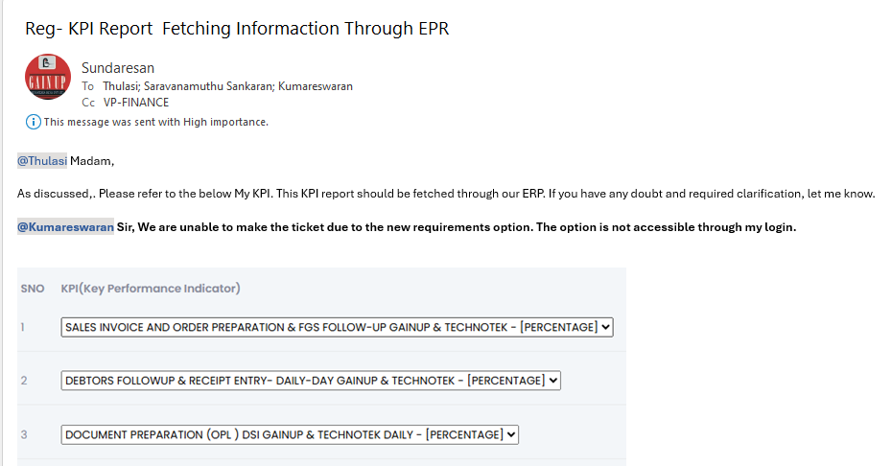

5.
JOURNAL ENTRY (IF APPLIED):
NARRATION (IF APPLIED):

APPROVAL SCREEN REQUIRED?
YES
NO
APPROVED BY:

APPROVAL MENU LINK:

REPORT REQUIRED?
YES
NO
TYPE OF REPORT:
MIS
POWER BI
GRID REPORT
CRYSTAL REPORT
LIFE@GAINUP

REPORT FORMAT:

REMARKS:

