ERP Requirement Template
TNO : GGA0452
USER NAME : SUNDARESAN.P
PROCESS FLOW : not available
MODULE NAME : Vbill
COMPONENT NAME : Sales Invoice , sales order
MENU LINK

SCREEN

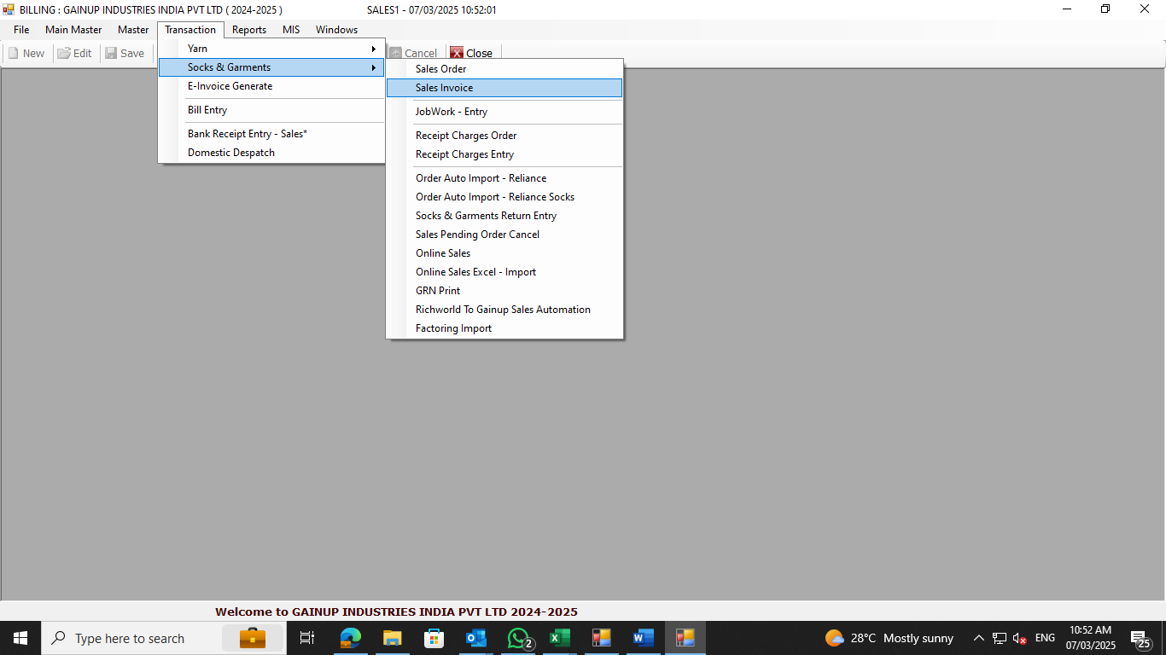

DESCRIPTION:
1.
2.
3.
4.
5.

CONDITIONS:
1.
2.
3.
4.
5.
JOURNAL ENTRY (IF APPLIED):
NARRATION (IF APPLIED):

APPROVAL SCREEN REQUIRED?
YES
NO NO
APPROVED BY:

APPROVAL MENU LINK:

REPORT REQUIRED?
YES
NO NO
TYPE OF REPORT:
MIS
POWER BI
GRID REPORT
CRYSTAL REPORT
LIFE@GAINUP

REPORT FORMAT:

REMARKS:

