**Sales Return Entry-Export**

|  |  |  |  |  |  |  |  |
| --- | --- | --- | --- | --- | --- | --- | --- |
| **Ticket Raised** | **Flow given** | **Approval Given by HOD** | **Document Prepared** | **Understanding Document** | **Allocated to Developer** | **Testing completed** | **User acceptance** |
| **10/06/23** | **15/06/23** | **15/06/23** | **30/06/23** | **30/06/23** |  |  |  |

**Ticket No:18163**

**Ticket Raised By Mr.Ramar**

**Sales Return Entry-Export**

**Allocated Time: Hours Allocated To: Mr. Joshua Approved By:Mr.Saravanamuthu**

**Description:**

**To enable the Sales Return Entry for Export and Bill passing for such Return Entry.**

**Module name:**

Export

Accounts

**Department Login:**

Export

Accounts

**Menu Link**

**At Export**

**Transaction 🡪 Sales Entry/Invoice 🡪 Sales Return**

**At Accounts**

**Authorize 🡪 Export 🡪 Sales Return**

**Vouchers:**

Creditnote

**Applicable companies:**

1.Gainup Industries  
2.Gainup Technotek

**Provisions:**

1.Sales Return Entry

2.Sales Return Entry Approval Screen

3.Accounts Bill passing screen

**Conditions**

1.Sales return entry should be raised only against sold invoices,

2.if Return entry made then PO, OCN will be enabled for next invoicing.

3.Stock of the returned quantity should be added to FGS.

4.Such sales return goes to Accounts Bill passing as Credit note voucher entry.

**Table Structure:**

**Forms to be Used:**

**Sample Screen for Sales Return:**

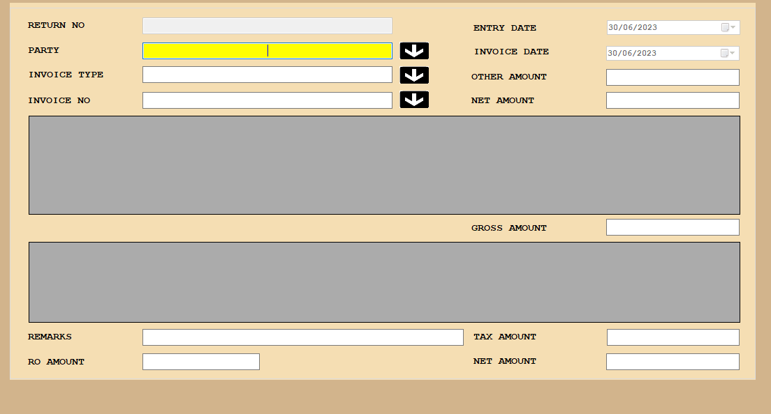

**screen for Approval**

**Table Structure:**

**Table name : Salesreturn_Details**

|  |  |  |
| --- | --- | --- |
| **Column Name** | **Datatype** | **Constraint** |
| RowID | Identity column | Auto Increment |
| Return_No | Integer | Primary key |
| Return_Date | datetime |  |
| Invoice_Master_ID | Integer |  |
| Gross_Amount | integer |  |
| Other_Charges | Integer |  |
| Net_Amount | Integer |  |
| RO_Amount | Integer |  |
| TNet_Amount | Integer |  |
| Entry_System | varchar(50) | hostname |
| Entry_Date | datetime | user time |
| User_Code | Integer | user system |
| Company_Code | Integer |  |
| Year_Code | Integer |  |
| Remarks | varchar(250) |  |
| BillPassing_Status | varchar(1) |  |
| Approval status | varchar(1) |  |
| App_by | varchar(50) | hostname |
| App_at | datetime | user time |
| App_on | Integer | user system |